KINGDOM OF ESWATINI



MINISTRY OF FOREIGN AFFAIRS AND INTERNATIONAL COOPERATION

DIPLOMATIC DIRECTORY



KINGDOM OF ESWATINI

DIPLOMATIC DIRECTORY DATA
MINISTRY OF FOREIGN AFFAIRS AND INTERNATIONAL COOPERATION HEAD OFFICE………………………………………………………………………………………………………………………………………………………6
PERMANENT MISSION OF THE KINGDOM OF ESWATINI TO THE UNITED NATIONS
IN NEW YORK……………………………………………………………………………………………………………………………………………………….14
HIGH COMMISSION OF THE KINGDOM OF SWZILAND TO THE UNITED KINGDOM………………………………………………………………………………………………………………………………………………...16
EMBASSY OF THE KINGDOM OF ESWATINI TO THE UNITED ARAB EMIRATES………..……….……………………………………………………………………………………………………………………………..17
EMBASSY OF THE KINGDOM OF ESWATINI TO THE UNITED STATES OF AMERICA…………………………………………………………………………………………………………………………………………………18
HIGH COMMISSION OF THE KINGDOM OF ESWATINI TO THE REPUBLIC
OF MOZAMBIQUE…………………………………………………………………………………………………………………………………………19
EMBASSY OF THE KINGDOM OF ESWATINI TO THE KINGDOM OF BELGIUM, BRUSSELS……………………………20

HIGH COMIISSION OF THE KINGDOM OF ESWATINI TO REPUBLIC
OF SOUTH AFRICA……………………………………………………………………………………………………………………………………………………23
PERMANENT MISSION OF THE KINGDOM OF ESWATINI TO THE AFRICAN
UNION…………………………………………………………………………………………………………………………………………………….24
HIGH COMIISSION OF THE KINGDOM OF ESWATINI TO MALAYSIA………………………………………….…………………………………………………………………………………………………...25
PERMANENT MISSION OF THE KINGDOM OF ESWATINI TO THE UNITED NATIONS
IN GENEVA …………………………………………………………………………………………………………………………………………………………….…26
EMBASSY OF THE KINGDOM OF ESWATINI TO THE REPUBLIC OF CHINA,
TAIWAIN………………………………………………………………………………………………………………………………………………….27
EMBASSY OF THE KINGDOM OF ESWATINI TO THE STATE OF KUWAIT…………………………………………………………………………………………………………………………………………………..28
EMBASSY OF THE KINGDOM OF ESWATINI TO THE STATE OF QATAR…………………………………….……………………………………………………………………………………………………………….29

INTERNATIONAL ORGANIZATIONS AND DIPLOMATIC REPRESENTATIVES
RESIDENT IN THE KINGDOM OF ESWATINI
EMBASSY OF THE UNITED STATES OF AMERICA…………………………………………………………………………………………………………………………………………………30
HIGH COMMISSION OF THE REPUBLIC OF MOZAMBIQUE………………………………………………………………………………………………………………………………………….32
EMBASSY OF THE REPUBLIC OF CHINA, TAIWAN……………………………………………………………………………………………………………………………………………….….33
BRITISH HIGH COMMISSION……………………………………………………………………………………………………………………………………………35
INDIAN HIGH COMMISSION……………………………………………………………………………………………………………………………………………36
ROPEAN UNION……………………………………………………………………………………………………………………..............................................37
EMBASSY OF THE STATE OF QATAR…………………………………………………………………………………………………………………………………………………….38
HIGH COMMISSION OF THE REPUBLIC OF SOUTH AFRICA ………………………………………………………………………………………………………………………………………………………………..39
CONSULATE OF THE REPUBLIC OF INDONESIA………………………………………………………………………………………………………………………………………………40
ROYAL DANISH CONSULATE……………………………………………………………………………………………………………………………………………..40
CONSULATE OF THE REPUBLIC OF MALTA…………………………………………………………………………………………………………………………………………………….41
CONSULATE OF THE REPUBLIC OF SEYCHELLES……………………………………………………………………………………………………………………………………………41
FRENCH CONSULATE…………………………………………………………………………………………………………………………………………….42
GERMAN LIASON OFFICE………………………………………………………………………………………………………………………………...............................42
CONSULATE OF THE REPUBLIC OF TANZANIA……………………………………………………………………………………………………………………………………………….42
CONSULATE OF THE REPUBLIC OF GHANA…………………………………………………………………………………………………………............................................................42
CONSULATE OF THE REPUBLIC OF ITALY………………………………………………………………………………………………………………………………………………………42

CONSULATE OF THE UNITED KINGDOM………………………………………………………………………………………………………………………………………………...43
CONSULATE OF THE RUSSIAN FEDERATION…………………………………………………………………………………………………………………………………………...43
CONSULATE OF THE REPUBLIC OF PORTUGAL………………………………………………………………………………………………………………………………………………43
CONSULATE OF THE REPUBLIC OF TURKEY…………………………………………………………………………………………………………………………………………………...44

ESAMI……………………………………………………………………………………………………………………………………………………...47
WHO………………………………………………………………………………………………………………………………………………………..47
WFP………………………………………………………………………………………………………………………………….................................48
UNFPA……………………………………………………………………………………………………………………………………………………..48
UNICEF……………………………………………………………………………………………………………………………………………………48
UNAIDS……………………………………………………………………………………………………………………………………………………48
UNCTAD…………………………………………………………………………………………………………………………………………………..48
FAO…………………………………………………………………………………………………………………………………………………………48

PART I
MINISTRY OF FOREIGN AFFAIRS AND INTERNATIONAL COOPERATION
HEAD OFFICE
Office Address : 3rd Floor, Inter-Ministerial Building
Mhlambanyatsi Road
Mbabane, Kingdom of Eswatini
Tel : +268 2404 2661/2/3
Fax : +268 2404 2669
Email : ps_foreignaffairs.gov.sz

EXECUTIVE
Hon. Minister Senator Thulisile Dladla
Designation : Minister of Foreign Affairs and International Cooperation
Cell : 7606 1919
Email : thuli.motsa@gmail.com
H.E. Melusi Masuku
Designation : Principal Secretary
Cell :

Email : melusi.masuku@un.int , helemisi12@gmail.com

Ms. Jennifer Neves
Designation : Under- Secretary Administration
Cell : +268 7606 3245
Email : jjneves777@yahoo.com/ginnineves79@gmail.com
Mr. Swazi Patrick Dlamini
Designation : Chief of Protocol
Cell : +268 7606
Email : Swazipatric@gmail.com
Mr. Kennedy Groening
Designation : Under-Secretary Political
Cell : +268 7606 2454
Email : groeningkennedyf@gmail.com
Mr. Samkelo Dlamini
Designation : International Cooperation Coordinator
Cell : +268 7606 2253
Email : pelepelesmd@gmail.com
ADMINISTRATION

Mr. Vuyile Dlamini
Designation: Legal Advisor
Cell: +268 7606 3216/7603 2358
Email: dlaminivuyile@gov.sz

Mr. Menzisi Mabuza
Designation: Economist
Cell: +268 7605 4808
Email: menzisi05@gmail.com

Ms. Nelisiwe Ginindza
Designation: Principal Human Resource Officer
Cell: +268 7615 4652
Email:

Mr Sifiso Vilakati
Designation: Human Resource Officer
Cell:+268 7654 2660
Email: sfisotb@gmail.com

Mr Sikhumbuzo Bhembe
Designation: Communications Officer
Cell: +268 7617 184
Email: skhumbuzobhembe@gmail.com

Mr. Lucas Matsebula
Designation: Transport Officer
Cell: +268 7692 0298
Email: matsebulalucas1@gmail.com

PERSONAL SECRETARIES

Vacant
Designation: Senior Personal Secretary
Cell:
Email:
Ms. Nomthandazo Malangwane
Designation: Personal Secretary
Cell: +268 7607 7627
Email: hlatshwayonco@gmail.com

Ms. Zandile Sihlongonyane
Designation: Personal Secretary
Cell: +268 7603 4031
Email: zandyncele@gmail.com

Vacant
Designation: Personal Secretary to Chief of Protocol

Ms. Pholile Dlamini
Designation: Personal Secretary
Cell: +268 7648 1437
Email: nanawakhe77@gmail.com
Ms. Nosipho G. Maseko-Thwala
Designation: Typist
Cell: +268 7681 8644
Email: nosiphogwen@gmail.com
Ms. Winile Shongwe
Designation: Personal Assistant to Hon. Minister
Cell: +268 7603 3223
Email: winileshongwe11@gmail.com

REGISTRY SECTION

Ms. Phumzile Nxumalo
Designation: Clerical Officer
Cell: +268 7622 3379
Email: hlalanenkhosi@gmail.com
Ms. Phepsiwe Dlamini
Designation: Junior Clerical Officer
Cell: +268 7851 8182
Email: valrose8080@gmail.com
Ms. Sibongile Sihlongonyane
Designation: Messenger
Cell: +268 7676 7995

Ms. Thoko Malaza
Designation: Messenger
Cell : +268 7615 1490
Email: thokomalaza42@gmail.com
Mr. Ncamiso Khumalo
Designation: Messenger
Cell: +268 7611 3435
Mr. Ramington Dube
Designation: Switchboard Operator
Cell: +268 7638 3468
Email: ramingtondube7@gmail.com

PROTOCOL DEPARTMENT

Ms. Nontokozo Shongwe - Tsabedze
Designation: Deputy Chief of Protocol
Cell: +268 7606 2497
Email: shongwenontoe@yahoo.com
Ms. Hlengiwe Manzini
Designation: Principal Protocol Officer
Cell: +268 7615 3121
Email: manzinihlengiwe@gmail.com
Mr. Dan Nxumalo
Designation: Protocol Officer
Cell: +268 7643 7375
Email: danvnxumalo@gmail.com
Mr. Sthembiso Gama
Designation: Protocol Officer
Cell: +268 7621 2183
Email: mnconyiswag@gmail.com
Ms. Nomvelo Mkhonta
Designation: Protocol Officer
Cell: +268 7659 2991
Email: lomacusi@gmail.com
Mr. Njabulo Simelane
Designation: Protocol Officer
Cell: +268 76574270
Email: njabulution@gmail.com
Ms. Nomfanelo Simelane
Designation: Protocol Officer
Cell: +268 7817 5277
Email: nomfanelos07@gmail.com
Ms. Simphiwe Ntshangase
Designation: Protocol Officer
Cell: +268 7629 7615
Email: simpsntshangase@gmail.com
Mr. Muzi Dlamini
Designation: Assistant Protocol Officer
Cell: +268 7613 7842
Email: mzeshee@gmail.com

POLITICAL DEPARTMENT

Mr. Phesheya Mncina
Designation: Assistant Socio-Political Analyst
Cell: +268 7607 5744
Email: phesheya181@gmail.com
Mr. Sihle Khumalo
Designation: Assistant Socio-Political Analyst
Cell: +268 7843 7053
Email: thutsihl@gmail.com
Ms. Nolwazi Dlamini
Designation: Assistant Socio-Political Analyst
Cell: +268 7607 2836
Email: temasiko89@gmail.com
Mr. Patrick Nkosi
Designation: Assistant Socio-Political Analyst
Cell: +268 7622 4127
Email: patrickvusani@gmail.com

INTERNATIONAL COOPERATION DEPARTMENT

Ms. Zandile Dlamini
Designation: International Cooperation Officer
Cell: +268 7667 2236
Email: zandi380@gmail.com
Mr. Thembinkosi Mavuso
Designation: International Cooperation Officer
Cell: +268 7821 2208
Email: tbmlaw656@gmail.com

Mr. Magimba Dlamini
Designation: International Cooperation Officer Cell: +268 7818 2621
Email: magimba.dlamini@gmail.com

ACCOUNTS DEPARTMENT

Ms. Beatrice Mdluli
Designation: Principal Accountant
Cell: +268 7623 1996
Email: fakazilemdluli@gmail.com

Ms. Thuli Sihlongonyane
Designation: Senior Accountant
Cell: +268 7612 4764
Email: maphindi0808@gmail.com

Ms. Hlengiwe Dludlu
Designation: Accountant

Cell: +268 7606 7707

Email: buhlenyanda@yahoo.com

Mr. Sikhumbuzo Nsibande
Designation: Assistant Accountant
Cell: +268 7627 2771
Email: skhulunsibandze@gmail.com

Mr. Sihle Gumbi
Designation: Assistant Accountant
Cell: +268 7614 5429/ 7914 5429
Email: sihlegumbics@gmail.com

EMERGENCY NUMBERS AND STRATEGIC PARTNERS
- ROYAL ESWATINI POLICE SERVICE
Nomsa Mkhaliphi, Diplomatic Police
Tel: +268 7607 9799

- THE KING’S OFFICE
Chief Mgwagwa Gamedze, Chief Officer
Tel:
Cell: : (+268) 2404 2476/7/8

PART II
ESWATINI’S MISSIONS ABROAD
- PERMANENT MISSION OF THE KINGDOM OF ESWATINI TO THE UNITED NATIONS IN NEW YORK
Office Address : 408 East 50th Street New York, 10022
Tel : (+1 212) 371-8910/8911/8775

Facsimile : (+1 212) 754-2755

Email : Eswatini@un.int

swaznymission@yahoo.com

Ambassador and Permanent Representative (Vacant)

Address: 261 Overlook Road New Rochelle, NY 10804

Tel: (+1 914) 636 4706 home

Cell:

Email:

Mr. Siphelele Welcome Dludlu, Counsellor

Address: 216-35 Sawyer Avenue Queens Village, NY 1142

Tel: (+ 347) 676 5868 home

Cell: (+1 646) 667 8269

Email: siphele.dludlu@un.int

siphele_dludlu@yahoo.co.uk

First Secretary Ms. Thandazile Mbuyisa, First Secretary Political (Vacant) Administration
Address: 53-40, Clearview Expressway, Address: 53-31 203rd Street, Oakland
Oakland Gardens, NY 11427 Gardens, NY 11364

Mobile: Mobile: + 1 646 785 2448

Email: email: thandazile.mbuyisa@un.int

Mr. Mduduzi Kenneth Mbingo, First Secretary Mr. Sonnyboy Hlatshwako, Third Information Secretary
Address: 48-38 201st Street, Address: 53-27 203rd Street, Oakland
Oakland Gardens, NY 11364 Gardens, NY 11364

Mobile: +1 347 832 6665 Mobile: +1 347 801 4923

Email: mduduzikeithkennedy.mbingo@un.int email: sonnyboysandiso@un.int

Ms. Thabsile Tshabalala, Administration
Attaché
Address: 112 12 68th Road Forest Hills
NY 11375
Tel: +1 718 261 4835

Mobile: +1 917 200 8721

Email: thabsile.tshabalala@un.int

- HIGH COMMISSION OF THE KINGDOM OF ESWATINI TO THE UNITED KINGDOM

H.E. Christian M. Nkambule, High Commissioner
Address: 15 Asylestone VENUE, NW6 7AE
Tel: +44 20 8459 3372
Mobile: +44 7554 48060
Email : christian.nkamule@gmail.com

Ms. Temnotfo Lenhle Cartland Nkambule, Counsellor
Address: 31 Gresham Gardens NW 11 8NX
Tel: +44 20 7630 6611
Mobile: +44 7521 064049
Email: Eswatinilondon@gmail.com

Ms. Sithembile Lushaba, First Secretary Information
Address:
Home:
Mobile:
Email Address :

Mr. Mandla Stanley Dlamini, Third Secretary
Address: 45Southbourne Crescent, NW4 2JX
Home: +44 20 83491357
Mobile: +44 745920 5414
Email : dlaminis@Eswatini.org.uk

Ms. Ruth N. Kunene, Administrative Attaché
Tel: +44 20 7630 611
Mobile: +44 7894 010315
Email : eswatinilondonhc@gmail.com

- EMBASSY OF THE KINGDOM OF ESWATINI TO THE UNITED ARAB EMIRATES
Address : Al Zaab Area- Villa No: 3-13th Street Between 201th and 30th Street
P.O. Box 109337 Khalidiya, Abu Dhabi, UAE
Tel : +971 2666 9637
Fax : +971 2666 9630
Email : swazuae@eim.ae

H.E. HRH Gcina S. Dlamini, Ambassador
Address: SB 12 Plot 111 Villa 210 – Sadiyat Island
Tell (Home): +971 2671 9996
Tell(office): +971 2666 9637
Ms. Nonhlanhla Dlamini, Counsellor
Address:
mobile: +971 50 165 8913
email: nonhlanhlamatsebula@yahoo.co.uk

Ms. Nonjabuliso Dlamini, Third Secretary
Address:
mobile: +971 561969624
email: dlamininonjabuliso9@gmail.com
Ms. Sibongile Motsa, Administrative Attache
Address:
mobile: +971 564910258
email: sibomotsa@gmail.com

- EMBASSY OF THE KINGDOM OF ESWATINI TO THE UNITED STATES OF AMERICA
Office Address : 1712 New Hampshire Avenue, North West, Washington D.C, 20009
Embassy Tel : (202) 234 5002
Embassy Fax : (202) 234 8254
Email : embassy@Eswatini-usa.com

H.E. Ambassador Njabuliso B. Gwebu, Ambassador
Address: 10804 Brickyard, Potomac 20854 Maryland
Tel: (301) 765 7049
Cell: (202) 550 6226
Email: nbgwebu@Eswatini-usa.com
Mr. Mcusi Shongwe, Counsellor
Address: 122 George Street, Gaithersburg 20877 Maryland
Tel: (301) 330 4710
Cell: (240) 421 3547
Email: mcusis@yahoo.com

Mr. Zakhele R. Mthupha, Third Secretary
Address:914 Grand Champion drive Rockville 20850 Maryland
Tel: (301) 527 0864
Cell: (240) 498 9227
Email: mthupha@gmail.com

Ms. Phumzile Gamedze, Administrative Attaché
Address: Maryland
Tel: (202) 234 5002
Cell: +1 240 660 8654
Email: embassy@Eswatini-usa.com
phumzilegamedze@gmail.com

- HIGH COMMISSION OF THE KINGDOM OF ESWATINI TO THE REPUBLIC OF MOZAMBIQUE

Address : Rue Lui Pastr 1271/63
Tel : +258 21 491 601
+258 21 491 746
Fax : +258 21 491 117
Email : swazimozembassy@gmail.com

H.E. Rev Abednego Mandla Ntshangase, High Commissioner
Tel (H) : +258 21 450281
Tel (O) : +258 21 491721
Mobile : +258 843204699
Email : christmasblessing2@yahoo.com
Mr. S’gayoyo Charles Magongo, Counsellor
Tel (H) : +258 21490564
Tel (O) : +258 21492451
Mobile : +258 827089641
Email : sgayoyomagongo@gmail.com

Mr. Vusi Rechy Dlamini, First Secretary Information
Tel (H) :+258 21491064
Tel (O) :+258 21491601
Mobile : +258 829037349
Email : vrdlamini2@gmail.com
Mr. Isaac Malangwane, Third Secretary
Tel : +258 21 491 601
+258 21 491 746
Mobile: +258 84 748 6508
Email: sifset@yahoo.com

Ms. Thuli R. Mamba, Administrative Attaché Mr. Sandile Lelfred Hlatshwayo, First Secretary
Tel: +258 21 491 601 Political
Cell:+258 84 712 5943 Cell: +258
Email : swazimozembassy@gmail.com Email: msandisto@gmail.com

- EMBASSY OF THE KINGDOM OF ESWATINI TO THE ROPEAN UNION

Office Address : 118 Avenue, Winston Churchill, 1180, Brussels, Belgium

Tel : +32 2 347 4771 / 5725

+32 2 343 6873 / 8740

Fax : +32 2 347 4623

Email : brussels@eswatini-embassy.

Website : www.swaziembassy.be

H.E. Mr. Sibusisiwe Mngomezulu, Ambassador Ms. Antoinette Henwood-Ronald, Counsellor

Address: 18 Meilokjeslaan, 3080 Tervuren Address: 1 Dr. Desmethlaan, 3080 Tervuren

Tel: +32 2 767 0543 Tel: +32 2 767 1440

Cell: +32 476 969 464 Cell: +32 488 024 846

Email: sibusisiwem@live.com Email: a.henwoodronald@yahoo.com

Ms. Xolile N. Ngwenya, First Secretary Ms. Phumelele Mtshali, Third Secretary

Address :50 Cammaertsstraat, 1933 Sterrebeek Address: 50 Cammaertsstraat, 1933

Tel: +32 2 782 2787 Tel: +32 2 782 2787

Cell: +32 489 843 972 Cell: +32 485 44 2511

Email: xolilengwenya.swaziembassy@gmail.com email:

Ms. Lindi Nkambule, Administrative Attaché

Tel: +322 735 2620

Cell: +32 483 01 0730

Email: brussels@eswatini-embassy.

- HIGH COMMISSION OF THE KINGDOM OF ESWATINI TO THE REPUBLIC OF SOUTH AFRICA

Office Address : 715 Government Avenue, Arcadia, Pretoria, 0083
Tel : +2712 344 1917/1910
Fax : +2712 343 0455

VACANT - High Commissioner
Address: 422 Julius Jeppe Street, Waterkloof, Pretoria
Tel:
Mobile:
Email:
Mr. Vulindlela Kunene, Counsellor
Address: 244 Clark Street, Brooklyn, Pretoria
Tel: 012 460 0487
Mobile:
Email : vuliek@gmail.com

Mr. Isaac B. Makhathu, First Secretary Information
Address: 226 Heloma Street, Waterkloof Pretoria
Tel: 012 346 4652
Mobile: 060 325 5388
Email: i.makhathu@swazihighcom.co.za
Ms. Constance Mthupha, Third Secretary
Address:
Tel:
Mobile: +27 65 727 6328
Email : accountspta@swazihighcom.co.za

Ms. Khumbulile D. Matsebula, Administrative Attaché
Address: 170 Pine Street, Arcadia, Pretoria
Tel: 012 344 4700
Mobile: 071 824 9634
Email Address: pretoria@swazihighcom.co.za
- CONSULATE OF THE KINGDOM OF ESWATINI IN THE REPUBLIC OF SOUTH AFRICA
Office Address : 16, Empire Road, Hill on Empire Building, 1st Floor Block B, Parktown, Johannesburg
Tel : +2711 403 2050
Fax : +2711 339 1785

Ms. Sebentile T. Dlamini, Consul
Address: 32 Burn Street, Waverly
Tel : +27 11 403 2050 / +277 11 440 4974
Mobile: +27 63 199 5828
Email: s.dlamini@swazihighcom.co.za

Mr. Sihle N. Mlangeni, Labour Attaché
Address: 6 Lennox Street, Waverly
Tel: +27 11 403 2050 / +27 11 786 4310
Mobile : +27 82 096 0012
Email: smlangeni@swazihighcom.co.za

Ms. Bonsile A. Dube, Third Secretary
Address: A8 Allenby Mews, Granville Place, Bramely
Tel: +27 11 403 2050 / +27 11 440 3546
Mobile : +27 82 096 0012
Email: accountsjh@swazihighcom.co.za

Lomanesi T. Dlamini, Cultural Attaché
Address: Unit 13 Dale Lace Village, 21 Lawrence Road, Westcliff
Tel : +27 11 403 2050
Mobile: +27 78 939 7232
Email : l.dlamini@swazihigcom.co.za

Celucolo Nkonyane, Administrative Attaché
Address: Unit 4 Oakhurst Flats, Lyndhurst, Johannesburg
Tel : +27 11 403 2050
Mobile: +27 824 3751
Email Address: celucolonkonyane@gmail.com

- EMBASSY OF THE KINGDOM OF ESWATINI TO THE AFRICAN UNION
Physical Address : Rwanda Street St. Werenda 17 Kapela
20 Hse no 1185, Addis Ababa
Tel : +251 116 262 125
Fax : +251 116 262 152

H.E. Promise Msibi, Ambassador
Address: Bole kifleKetemaKebele 10 Gerji
Tel (H) : N/A
Tel (O) :+251116670802/03
Mobile : +251 911255487
Email: promisemsibi01@gmail.com

Ms. Nombulelo Venencia Lushaba, Counsellor
Address: Bole kifleKetemaKebele 13 Gerji
Tel (H) : N/A
Tel (O) : +251116670802/03
Mobile : +251969124888
Email: lushabalelo@yahoo.com

Mr. Sandile Lelfred Hlatshwayo, First Secretary Political
Address: Bole Sub City
Tel (H) : N/A
Tel (O) : +251116670802/03
Mobile : +251 922530358
Email: msandisto153@gmail.com
Mr. Vusi Eric Magagula, Third Secretary
Address: Bole Sub City
Tel (H) : N/A
Tel (O) : +251116670802/03
Mobile : +251 939490405
Email: vemagagula@gmail.com

Brigadier General Bhekithemba Mbokodvo Sikhondze, Defense Attaché
Address: Bole Sub City KifleKetemaKebele 03/05
Tel (H) : N/A
Tel (O) : +251116670802/03
Mobile : +251 912641182
Email : bkmbokodvo@yahoo.co.uk

Mr Phathizwe Joshua Malambe, First Secretary Political
Address: Bole Sub City KifleKetemaKebele 13
Tel (H) : N/A
Tel (O): +251116670802/03
Mobile: +251 983934345
Email: pjmalambe@gmail.com

WOII Thulani Alex Gule, Defence Attaché Assistant
Address: Bole Sub City KifleKetemaKebele 13
Tel (H) : N/A
Tel (O) : +251116670802/03
Mobile : +251 935203652
Email : thulanigule@gmail.com
Ms. Virginia Magongo, Administrative Attaché
Address:
Tel (O) : +251 116 262 125
Mobile : +251 95 399 2644
Email: eswatiniaddis@gmail.com

- HIGH COMMISSION OF THE KINGDOM OF ESWATINI TO MALAYSIA

Office Address : Suite 22.03 & 03 (A), Menara Citibank, No. 165,
JalanAmpang, 50450 Kuala Lumpur, Malaysia
Tel : +60 3 2163 2511, +60 3 2163 2487, +60 3 21643150,
+60 3 2164 3158
Fax : +60 3 2163 3326
Website : www.Eswatinikualalumpur.org

H.E. Mlondi Solomon Dlamini, High Commissioner
Residential Address : No.2A (Unit 4),Persiaran Kuantun, Tamanasik Titiwangsa, 55000 Kuala Lumpur,
Tel: +60 3 4251 0036
Mobile: +60 12 334 0408, +60 11 2763 0129 Email: mlondl@swazihicom.org.my
Mr. Almon Mahlaba Mamba, Counsellor
Residential Address : Unit No.2.01, 2nd Floor, 7 U-Thant Condominium, No. 7, Jalan U- Thant, 50450, Kuala Lumpur,
Tel: +60 3 2141 0689
Mobile: +60 11 2337 5463
Email: mahlaba_mamba@yahoo.com

Ms. Bongekile Ruth Tsabedze, Third Secretary
Residential Address: Unit # B23A-1 (24th Floor, Unit 1), Binjai Residency,No.1 LoronBinjal, 50450 Kuala Lumpur
Tel: +60 3 2163 3131
Mobile: +60 11 1284 9042
Email: bongi@swazihicom.org.my

Ms. Mano Queeneth Busisiwe Dlamini, Administrative Attaché
Residential Address : Unit A-3A-2, Hampshire Park, No. 6 Persiaran Hampshire, 50450 la Kuala Lumpur,
Tel: +60 3 2161 0118
Mobile: +60 11 2362 1490
Email: mano@swazihicom.org.my

- PERMANENT MISSION OF THE KINGDOM OF ESWATINI TO THE UNITED NATIONS IN GENEVA
Address : Chemin William – Barbey 51, 1292 Chambesy Geneva, Switzerland: Tel : (+41) 22 758 9410
Fax : (+41) 22 758 9424
Email address : contact@missionofeswatini.ch

H.E. Mr. Zwelethu Mnisi, Ambassador
Residential Address: 58 Route de Sauverny 1290 Versoix
Mobile Phone: (+41) 76 361 0202
Email: swazimissiongeneva@dslnets.ch
Home Telephone no: (+41) 22 755 0624
Ms. Philile Masuku, Counsellor
Residential Address: 33A Chemin Louis Degallier 1290 Versoix
Mobile Phone: (+41) 79 618 0126
Email: counsellor@missionofeswatini.ch
Home Telephone no: (+41) 22 955 0878

Mr. Jacob Dlamini, First Secretary Information
Residential Address: Chemin de Sales 15D 1214 Vernier
Mobile Phone: (+41) 22 758 9410
Email:
Home Telephone no: (+41) 22 3410185
Ms. Bawelile Simelane, First Secretary Economics
Residential Address: 4A Avenue Marc-Peter 1290 Versoix
Mobile Phone: (+41) 79 488 0711
Email: bawesim@gmail.com
Home Telephone no: (+41) 22 755 3402

Mr. Muzi Nhlabatsi, Third Secretary
Residential Address: Grand-Montflry 56, 1290, Versoix
Mobile Phone: (+41) 796 770 259
Email: nzinl@gmail.com
Ms. Vinah Ntongolozi Gamedze, Administrative Attaché
Residential Address: Chemin du Pre Cartelier 4 1202 Geneva
Mobile Phone: (+41) 788 423 622
Email: gvinah@rocketmail.com

- EMBASSY OF THE KINGDOM OF ESWATINI TO THE REPUBLIC OF CHINA ON TAIWAN
Address : 10F, No. 9, Lane 62 Tianmu W. Rd, Taipei 111, Taiwan, R.O.C.
Tel : +886 2 2872 5934
Fax : +886 2 2872 6511
Email : swazitpi@ms41.hinet.net

H.E. Thamie Dlamini, Ambassador
Address: No. 2, Alley 4, Lane 16, Zhong Young 1st Rd., Taipei 111, Taiwan, R.O.C
Tel: +886 2 2862 2353
Cell: +886 963 828 277
Email: thamzeend@yahoo.com
Ms. Lindiwe Cynthia Kunene, Counsellor
Address: No. 1, Lane 89, Xing Yi Road, Beitou, Taipei 112, Taiwan, R.O.C
Tel: +886 2 2873 8967
Cell: +886 966 706 497
Email: trizah465@hotmail.com

Ms. Zanele Keke Ntombifuthi Bhembe, First Secretary
Address: No. 1, Lane 89, Xing Yi Road, Beitou, Taipei 112, Taiwan, R.O.C
Tel: +886 2 2872 5473
Cell: +886 905 700 935
Email: bhembeza@gmail.com

Mr. Brian S’khumbuzo Hlophe, Third Secretary
Address: No. 3, Lane 112, Xing Yi Road, Pei Tou, Taipei, Taiwan, R.O.C
Tel: +886 2 2873 4456
Cell: +886 905 884 320
Email: hlopheskhulu@gmail.com

Ms. Princess S’phiwe, Administrative Attaché
Residential Address: 7F., No. 6, Lane 219, Sec 7, Chung Shan North Road, Taipei 111,
Tel: +886 2 2874 2714
Cell: +886 963 661 766
Email: princy.maphiwana@gmail.com

- EMBASSY OF THE KINGDOM OF ESWATINI TO THE STATE OF KUWAIT
Address : Al-Siddeeq, Block 3, street 310, Villa 294, Kuwait City
Tell : +965 25313306
Fax : +965 25313307
Email : admin@Eswatinikuwait.com

H.E. Sotja M. Dlamini, Ambassador
Residential Address: Rawda Block 5, Street 58, Villa 5, Kuwait City
Tel :+965 22573426
Mobile: +965 65731188
Email: smd@eswatinikuwait.com qhongo2000@gmail.com

Mr. Sifiso M. Dlamini, Counsellor
Residential Address: Bayan Block 1, Street 2, Villa 43, Kuwait City
Tel: +965 25381067
Mobile: +965 67776485
Email: sifisodlamini@eswatinikuwait.com
fisodlamini@hotmail.com

Mr. Linda A. Dlamini, Third Secretary
Residential Address: Hatten Area, Block 2, Street 216, House 573, Apartment 2
Tel : +965 25324284
Email: lindadlamini@eswatinikuwait.com

Ms. Lungile Fortunate Kunene, Administrative Attaché
Residential Address: Jabriya Area, Block 5, Street 6, House No. 5, 2nd Floor
Tel: +965 66027094
Email: lungilekunene@eswatinikuwait.com
lungiemadonsela@gmail.com

- EMBASSY OF THE KINGDOM OF ESWATINI TO THE STATE OF QATAR

Address : West bay, Lusail Street, Villa No. 4, P.O. Box 24332
Landline : +974 4493 3145/ +974 4493 2359 / +974 4493 1467
Fax : +974 4493 3216
Email : eswatiniqa@gmail.com

H.E. Felizwe P. Dlamini, Ambassador

Home: +974 4483 6790 / +974 4483 6358
Fax: +974 4483 6358
Mobile: +974 6686 8199
Email: felizwe@gmail.com
Sicelo V. Dlamini, Counsellor

Home: +974 4411 7685
Mobile: +974 55385820
Email: scelov.dlamini@gmail.com

Ms. Ntombi W. Shabalala, Third Secretary

Home: +974 4417 7050
Mobile: +974 5543 9639
Email: witnessnt@gmail.com

Ms. Zandile Nhlabatsi, Admin Attaché

Home: +974 4411 0143
Mobile: +974 5506 5099
Email: acaciamantini73@gmail.com

PART III
INTERNATIONAL ORGANISATIONS AND DIPLOMATIC REPRESENTATIVES RESIDENT IN THE KINGDOM OF ESWATINI
- EMBASSY OF THE UNITED STATES OF AMERICA
Postal address : Corner of MR 103 and Cultural Center Drive Ezulwini
P. O. Box D202
The Gables, H106
Eswatini

Tel : (+268) 2417-9000
Fax : (+268) 2416-3344

H.E. Jeanne M. Maloney, Head of Mission
Designation: Ambassador
Tel: (+268) 2417 9000
Email: Mbabane-Exec@state.gov
Mr. John Moyer, Deputy Chief of Mission
Tel:(+268) 2417 9000
Email: Mbabane-Exec@state.gov

Ms. Abigail Unger, Executive Assistant to Ambassador
Tel: (+268) 2417 9000
Email: UngerAL@state.gov
Mr. William Miskelly, Management Officer
Tel: (+268) 2417 9604
Email: MiskellyWJ@state.gov

Mr. Todd Jungenberg, Consular
Tel:(+268) 2417 9640
Email: Jungenberg@state.gov
Ms. Stephanie Sandoval, Public Affairs Officer
Tel: (+268) 2417 9669
Email:SandovalSK@state.gov

Mr. Michael Coker, Political/ Economic Officer
Tel: (+268) 2417 9663
Email: CokerMC@state.gov
Mr. Mathew Perry, Regional Security Officer
Tel: (+268) 2417 9660
Email: PerryML@state.gov

Mr. Rodrigo Sandoval, Information Management Officer
Tel: (+268) 2417 9313
Email: SandovalRV@state.gov
Mr. Caroline Ryan, CDC Country Director
Tel: (+268) 2417 9008
Email: cgr8@cdc.gov

Ms. Cheryl Amoroso, PEPFAR Coordinator
Tel: (+268) 2417 9858
Email: amorosoCL@state.gov

Ms. Wendy Benzerga, USAID Country Director
Tel: (+268) 2417 9685
Email: wbenzerga@state.gov

- HIGH COMMISSION OF THE REPUBLIC OF MOZAMBIQUE MBABANE
Address : Mountain Inn, Princess Drive
Msebe Road, Plot 468 Mbabane
Tel : (+268) 2404 1296/7
Fax : (+268) 2404 3692, 2404 8482
Email : moz.high@swazi.net

H.E. Mr. Jorge Henrique da Khálau, Head of Mission
Designation: High Commissioner
Cell: (+268) 7889 4640
Ms. Georgina Lazaro Mugawa, Counsellor
Cell: (+268) 7805 4735
Email: gina.mugawa@gmail.com

Mr. João Jorge Cuco, Financial Attaché
Cell: (+268) 7857 3561
Email:
Olivia Dinis Mate, Consular Attaché
Cell: (+268) 7861 3621
Email:

Acánio Munguambe, Second Secretary
Cell: (+268) 7824 0993
Email:

Cecilia Clara, Secretary H.C
Cell: (+268) 685 7119
Email:

Dias Paulo, Assistant Consular
Cell: (+268) 7813 5631
Email:
Sharmila Laila, Assistant Consular
Cell: (+268) 636 3030
Email:

Sandra Luis, Assistant Consular
Cell: (+268) 7825 9166
Email:

- EMBASSY OF THE REPUBLIC OF CHINA (TAIWAN)

Address : Corner of Mahlokohla Street and Makhosikhosi Street Opposite
Swazi Delta Behind Central Bank, Mbabane
Tel : 2404 4740/1

H.E Jeremy H.S. Liang, Ambassador
Tel: (+268) 2404 4116
Cell: (+268) 7902 0061
Email: hsliang@mofa.gov.tw
Mr. Jiann-haur Harn, Minister Counsellor
Tel: (+268) 2404 9044
Cell: (+268) 7902 0062
Email: harno168@gmail.com

Mr. Teh-hsin Wu, Deputy Counsellor
Tel: (+268) 2404 9973
Cell: (+268) 7902 0066
Email: thwu@mofa.gov.tw
Mr. Yen-yuan Chen, First Secretary
Tel: (+268) 2404 7393
Cell: (+268) 7602 0062
Email: yychen@mofa.gov.tw

Mr. Tai-wen Lin, Second Secretary
Tel: (+268) 2404 7111
Cell: (+268) 7602 6390
Email: twlin@mofa.gov.tw
Mr. Yu-lin Wang, Third Secretary
Tel: (+268) 2404 7440
Cell: (+268) 7902 0012
Email: ylwang03@mofa.gov.tw

Ms. Mu-hsuan Chen, Third Secretary
Tel: (+268) 2404 8925
Cell: (+268) 7902 0069
Email: mhchen01@mofa.gov.tw
Mr. Lin-huang Huang, Counsellor
Tel: (+268) 2405 0105
Cell: (+268) 7902 0065
Email: yg1236@gmail.com

Mr. Kao-Huang Chen, Economic Counsellor
Tel: (+268) 2404 9485
Cell: (+268) 7602 0687
Email:edmoeasz@gmail.com
Mr. Shyh Jang Shiau, First Secretary
Tel: (+268) 2404 4740
Cell: (+268) 7602 6387
Email: rocszembassy@gmail.com

Mr. Ching-yuan Hsu, Defence Attache
Tel: (+268) 2404 4460
Cell: (+268) 7602 6388
Email: hsu100@hotmail.com

Mr. Ju Yun Jeng, Second Secretary
Tel: (+268) 2405 0104
Cell: (+268) 7902 0067
Email: jiy@mail.coa.gov.tw

- BRITISH HIGH COMMISSION

Head of Mission: H.E. Simon Boyden
Address: Royal Villas, Villa No. 2
Cell: (+268)
Email:

Political Trade & Communications Officer: Ms. Tsenjwako Zwane
Address: Royal Villas, Villa No. 2
Cell: (+268) 7806 8807
Email: tsenjwako.zwane@fco.gov.uk

Office Manager: Kathy Wells
Address: Royal Villas, Villa No. 2
Cell: (+268) 7806 8806
Email: Kathy.wells@fco.gov.uk

Office Manager & IT: Saneliso Maseko
Address: Royal Villas, Villa No. 2
Cell: (+268) 7806 8805
Email: Saneliso.maseko@fco.gov.uk

- INDIAN HIGH COMMISSION

Head of Mission: H.E. Ms. Radha Venkataraman
Address: 5th floor, Quadrant B and C,
UN House, Mbabane
Cell: (+268) 79427000
Tel: (+268) 2410 1621
Email: hoc.mbabane@mea.gov.in

2nd Secreatary: Mr. Brahmam Jagabattuni
Address: 5th floor, Quadrant B and C,
UN House, Mbabane
Cell: (+268) 79427002
Tel: (+268) 2410 1621
Email: hc.mbabane@mea.gov.in
admn.mbabane@mea.gov.in
Assistant Attache: Mr. Pradeep Deshwal
Address: 5th floor, Quadrant B and C
UN House, Mbabane
Cell: (+268) 76469369
Tel: (+268) 2410 1621
Email: accts.mbabane@mea.gov.in
admn.mbabane@mea.gov.in

- DELEGATION OF THE EUROPEAN UNION TO ESWATINI
Postal address : Lilunga House, 4th floor, Somhlolo Road,
Mbabane, Eswatini
P.O. Box A 36 Swazi Plaza H101,
Mbabane, Eswatini
Tel : +268 2404 2018 / 4769 /2908 / 0191
Fax : +268 2404 6729
Email : delegation-Eswatini@eeas.ropa.

Head of Delegation : H.E. Dessislava Choumelova
Tel : +268 2404 2018
Cell : +268 7629 1998
Email : Krista.LEL@eeas.rpa.

Head of Administration : Jaco Verschoor
Tel : +268 2404 2908
Cell : +268 7802 8617 Email : jaco.verschoor@eeas.ropa.
Personal Assistant to HOD : Krista Lel
Tel : +268 2404 2018
Cell : +268 7629 1998
Email : Krista.LEL@eeas.rpa.

Receptionist : Teresa Miranda
Tel : +268 2404 2908
Email : teresa.miranda@eeas. ropa.

EMBASSY OF THE STATE OF QATAR
Ambassador : H.E. Y Mr. Yousef Bin Al Mahmound

Address : Royal Villa No. 20
P. O. Box 420, Ezulwini
Mbabane
Eswatini
Tel : (+268) 2416 1580
Fax : (+268) 2416 1694
Email : mbabane@mofa.gov.qa

- SOUTH AFRICAN HIGH COMMISSION IN MBABANE, ESWATINI
Address : The New Mall, 2nd Floor, Dr. Sishayi Road
P O Box 2507, Mbabane
Eswatini
Tel : (+268) 2404 4651-4
Fax : (+268) 2404 4335
Website : sahc@africaonline.co.sz

High Commissioner: Adv. Thoko Majokweni-Sipamla
Address : Plot 2995, Mantsholo Road,
Thembelihle, Mbabane

Cell: (268) 7602 5252
Email:
First Secretary (Political): Ms. Refilwe Ndou
Address: Plot 1204, Mgwava Street,
Thembelihle, Mbabane

Cell: (268) 7602 5259
Email: ndour@dirco.gov.za

First Secretary (Admin): Ms. Maria Bokaba-Jali
Address: Plot 2494, Lutindzi Street,
Thembelihle, Mbabane
Cell: (268) 7806 1944
Email: bokabam@dirco.gov.za

Third Secretary (Admin): Ms. Lolwethu Ncetani
Address : Plot 8, Farm 188, Unit 3, Dalriach
East, Mbabane
Cell: (268) 7806 0065
Email: ncetanil@dirco.gov.za

First Secretary (Immigratn) : Ms. Salome Myeni
Address : Plot 8, Farm 188, Unit 2, Dalriach
East, Mbabame
Cell: (268) 7802 7379
Email: myenis@dirco.gov.za
First Secretary (Political): Mr. Thabang Malebye
Address: Portion 382 of Farm 188, Dalriach
East, Mbabane
Cell: (268) 7802 5222
Email: malebyet@dirco.gov.za

Counsellor Defence Attache: Col. Tisetso Chabalala
Address : House No. 50, Ext 1, Woodlands Township, Mbabane
Cell: (268) 7631 8644
Email: chabalalat@dirco.gov.za
Counsellor SAPS: Col. Linda Ngantweni
Address: Ext 26, Mantsholo Road, Riverview, Mbabane
Cell: (268) 7602 4132
Email: ngantwenil@dirco.gov.za

- HONORARY CONSULATE FOR DENMARK, NORWAY & NETHERLANDS IN MBABANE, ESWATINI
HEAD OF MISSION : Mr. PerSonne Nøddeboe, Honorary Consul
Address : Sokhamlilo building, Ground floor
Corner Dzeliwe and Mdada Streets
P.O. Box 815
Mbabane H100
Eswatini
Tel : (+268) 2404 3547
Fax : (+268) 2404 3548
Email : citrus@realnet.co.sz
Website : Eswatini.um.dk

- INDONESIAN HONORARY CONSULATE IN MBABANE, ESWATINI
Address : c/o Union Suppliers
P.O. Box 196
H 100 Mbabane
Eswatini
TELEPHONE : (+268) 2404-4076
FAX : (+268) 2404-4076
EMAIL : unionsupplies@swazi.net

Hon Consul General : Mr Kareem Ashraff,
Cell : +268 7602 0138
EMAIL : unionsupplies@swazi.net

Ms. Archana Reddy, Personal Secretary
TEL : 2404 3966
EMAIL : unionsupplies@swazi.net

MS. ALPA ASHRAFF-SUREJA, ASSISTANT
TEL : +268 2404 0624
EMAIL : info@indonesiaconsulate.org.sz
MR. DAVID TSABEDZE, DRIVER
TEL : +268 2404 4076 EMAIL : info@indonesiaconsulate.org.sz

MR. CANAAN MDLULI, RECEPTIONIST
TEL : +268 2404 0624
EMAIL : info@indonesiaconsulate.org.sz

- SEYCHELLES HONORARY CONSULATE

Head of Mission : Prof. Nasser Mansoor – Honorary Consul General

Address : Plot 481 Jacaranda Street, Coates Valley Manzini

Tel : 25056786 (H) 25052415 (W)

Monica Groening – Personal Assistant

Cell : 76061586

Email : nm786naz@gmail.com

- MALTA HONORARY CONSULATE

Head of Mission : Mr. Arshad Mansoor - Honorary Consul General

Address : Plot 494, Bauhinia Road,Coates Valley Manzini

Tel : 25055837 (H) 25058151 (W)
Cell : (+268) 76025786

Email : arshadswd@gmail.com

Monica Groening – Personal Assistant

Cell : 76061586

Email : nm786naz@gmail.com

- FRENCH CONSULATE

Honorary Consul: Thibaut Muzart
Residential Address : No. 363 Mthombo Crescent, Dalriach East Mbabane
Telephone : 24043667
Mobile : 76607420
Email address : hconsulate.france@gmail.com

- LIASON OFFICE OF THE EMBASSY OF THE FEDERAL REPUBLIC OF GERMANY
MRS. LIESEL TOEPFER, LIASON OFFICER
Telephone : 24043174/24090042
Cell : 7682 8862
Email : germanlo@swazi.net

- SOUTH KOREA CONSULATE
Consular Assistant – Han Gie KIM
Telephone :
Cell : +268 7615 7700
Email : khg1011@gmail.com

- TANZANIA CONSULATE
Honorary Consul: Mr. Herman Bashasha
14 Riverside Estate Industrial Site Mbabane
Telephone : +268 24041063
Cell : +268 7604 4567
Email : tvdoctors@swazi.net

MS. Wendy Mngomezulu, SECRETARY
Telephone : +268 24041063
Cell : +268 78140146
Email : tvdoctors@swazi.net

- FINLAND CONSULATE
Aleta Armstrong, Honorary Consul
Telephone : 24162984
Cell : 7902 5270
Email : armstrongaleta@gmail.com

- ITALIAN CONSULATE

MR. ROBERTO RUSSO, HONORARY CONSUL
Telephone : 25186200/2518 6201
Cell : 7602 2882/7691 8316
Email : mbabane.onorario@esteri.it
MS. HLOBSILE MAGONGO, PERSONAL ASSISTANT
Telephone : 25186200/2518 6201
Cell : 7618 9540 Email : hlobsile@starpaint.co.za

MS. GEORGIA D’ORSI, ADMINISTRATIVE ASSISTANT
Telephone : 25186200/2518 6201
Cell : 7691 8316
Email : mbabane.onorario@esteri.it

- GHANA CONSULATE

MR. KOBLA MENSAH QUASHIE, HONORARY CONSUL
Telephone : 25054974/25053537
Cell : 7602 8222/3
Email : kobla@ghanaconsulate.co.sz

MS. AKUA GYEDUA AGYEI, CONSULATE SECRETARY
Telephone :25053076/25054974
Cell : 7867 8844
Email: akua@ghanaconsulate.co.sz

- UGANDA CONSULATE

MR. TOBIAS KAMUGISHA, HONORARY CONSUL
Cell : 7602 0999
Email : ugandaconsul@gmail.com

NOTHANDO DLAMINI, CONSULATE SECRETARY
Cell : 7615 4327
Email: siyalinda200@gmail.com

- RUSSIAN CONSULATE
VACANT
Telephone :
Cell :
Email :

- AUSTRIAN CONSULATE

MR. ANDREAS LAMPRIANOU, HONORARY CONSUL
Tel : 340 22037
Cell : 7602 8011
Email : hc.austria.eswatini@gmail.com

MS. SIMONA ZIBURSKI
Tel : 340 22037
Cell : 7623 3733
Email :hc.austria.eswatini@gmail.com

- PORTUGAL CONSULATE
MR. CARLOS MADUREIRA LOPEZ, HONORARY CONSUL
Telephone : 24046780/24046770
Cell : 7618 9025
Email : lopes@posix.co.sz

- TURKEY CONSULATE
MR. ISMAIL OLMEZ, HONORARY CONSUL
Telephone : 2422 0805
Residential : 2416 2436
Cell : 7802 1910
Email : ismael@olmez.co.sz

MS. NOMCEBO MAVUSO, CONSULAR SECRETARY
Telephone : 2422 0805
Email : infol@olmez.co.sz

MR. VUSIE MAZIBUKO, ADMINISTRATION ASSISTANT/ DRIVER
Telephone : 2422 0805
Cell : 7663 7351
Email : infol@olmez.co.sz

ESWATINI HONORARY CONSULS ABROAD
Austria
Address : A-1100 Vienna Republic of Austria
Telephone : +43 1 319 1138
Fax : +43 1 319 1138

Republic of China (Taiwan)
Address : 12th Floor, No. 127, Jen A1 Road Sec. 3 Taipei
Telephone : +886 2 751 8257, +886 2751 8258
Fax : +886 2 751 8259
Greece
Address : 88 Drosspoulou Street, Athens 04
Telephone : +30 1 865 5342

Germany
Address : 59 Worringer Street
Telephone : +49 211 350 866, +49 228 914 430
Fax : +49 228 914 430

Israel
Address : 1 Seadya Gaon Street Rehavia Jerusalem 92267, Israel
Telephone : +972 2 632 071
Fax : +972 2 232 698

Luxemburg
Address : 24 Rue Beaumont, 1219 Luxembourg
Telephone : +352 225 829
Fax : +352 225 828

FOOD AND AGRICULTURE ORGANIZATION
Representative : PHIRI, Mr CHIMIMBA D.
Email : FAO-SZ@fao.org
ESAMI
HEAD OF MISSION : Winile N. Nxumalo, Country Coordinator

Tel : (+268) 2404 8494

Cell : 7603 4310

E-mail : winilen@yahoo.com

Khetsiwe T. Mango- Administrative Assistant

Tel : (+268) 2404 8494

Cell : (+268) 7615 4077

E-mail : mangokhetsi@gmail.com

WORLD HEALTH ORGANISATION (WHO)
Representative : Dr. Cornelia Atsyor
Tel : (+268) 2404 9813/ 2404 1698
Cell : (+268) 7602 4293
Email : FAO-SZ@fao.org

UNITED NATIONS

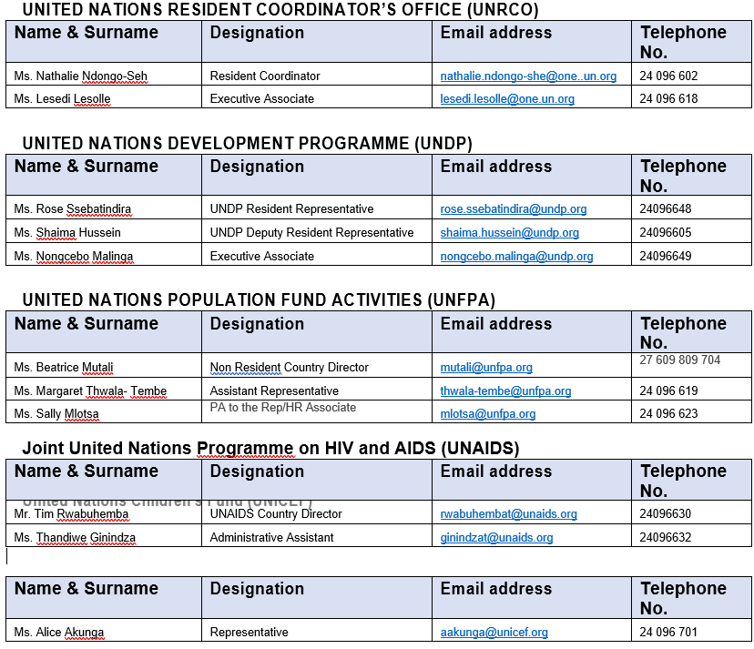
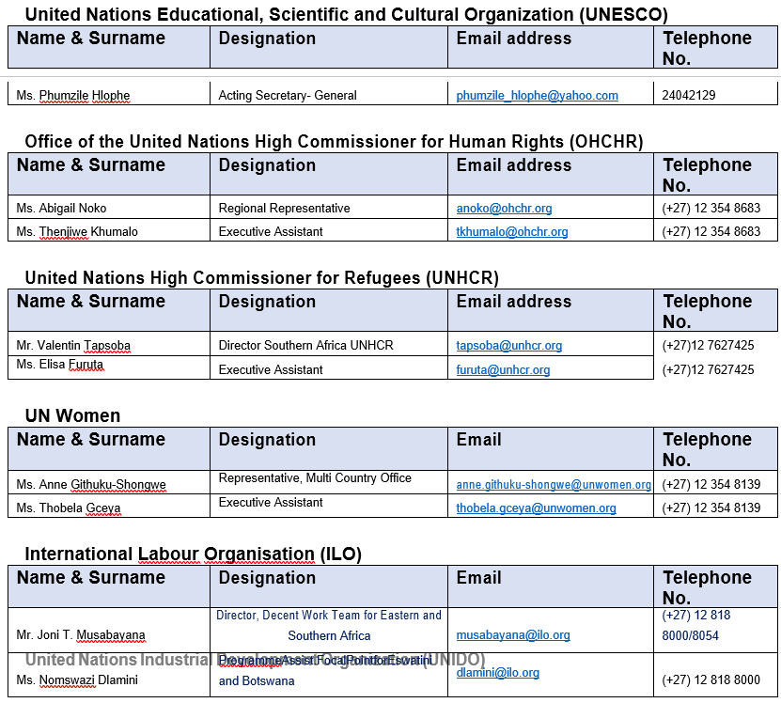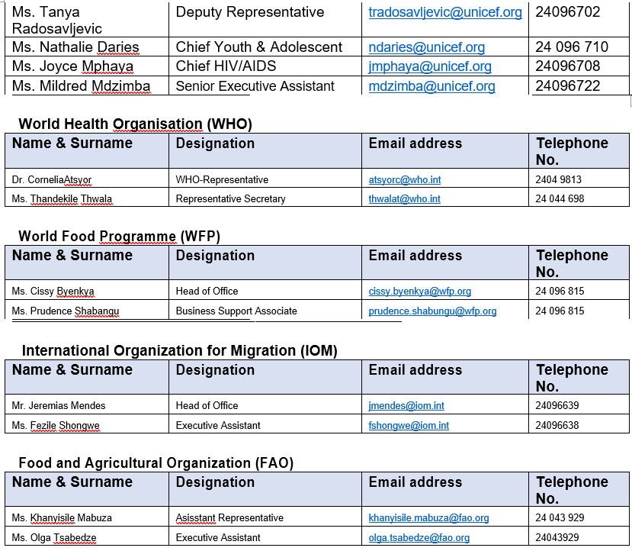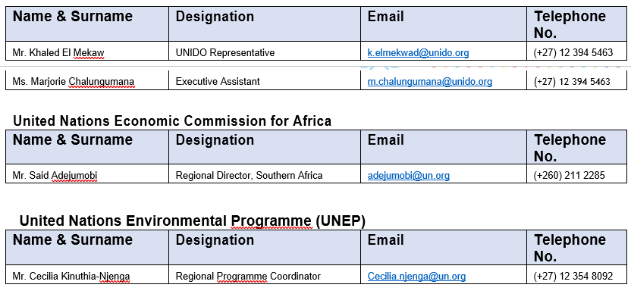

PART IV
DIPLOMATIC SECURITY SERVICE
Mr. V. M Masango, Deputy National Commissioner of Police
Mobile Phone : (+268) 7606 2342

Themba Musa Magagula, Superintendent – Officer in Charge, Diplomatic Security
Mobile Phone : (+268) 7604 4746
Work Telephone no. : (+268) 2404 9630

Inspector Queeneth D. Khayiyane, 2nd Officer in Charge, Diplomatic Security
Mobile Phone : (+268) 7612 5885
Work Telephone no. : (+268) 2404 9630

Sergeant Bongane Zwane, Field Officer, Diplomatic Security
Mobile Phone : (+268) 7619 3662
Work Telephone no. : (+268) 2404 9630

Constable Melusi Dlamini, Field Officer, Diplomatic Security
Mobile Phone : (+268) 7613 6187
Work Telephone no. : (+268) 2404 9630

Constable Melusi Dlamini, Field Officer, Diplomatic Security
Mobile Phone : (+268) 7638 3706
Work Telephone no. : (+268) 2404 9630

POLICE STATION CONTACTS
- MBABANE POLICE STATION

Ms. Busi Dube, Superintendent, Station Commander
Mobile Phone : (+268) 7604 3185/ 7904 3185
Work Telephone no. : (+268) 2404 4122
Mr. Charles V. Simelane, Superintendent, Station Operations Officer
Mobile Phone : (+268) 7611 6116
Work Telephone no. : (+268) 2404 4122

- LOBAMBA POLICE STATION

Mr. Agrippa M. Kunene, Superintendent, Station Commander
Mobile Phone : (+268) 7605 5958/ 7905 5958
Work Telephone no. : (+268) 2416 1221
Mr. Zakhele Dlamini, Assistant Superintendent, Station Operations Officer
Mobile Phone : (+268) 7606 5029/ 7906 5029
Work Telephone no. : (+268) 2416 1221
- MANZINI POLICE STATION

Mr. Dumsani Dube, Superintendent, Station Commander
Mobile Phone : (+268) 7633 5851
Work Telephone no. : (+268) 2505 2222
Mr. Mfanasibili M. Mkhwanazi, Assistant Superintendent, Station Operations Officer
Mobile Phone : (+268) 7603 4084
Work Telephone no. : (+268) 2505 2222

- MATSAPHA POLICE STATION

Mr. Patrick B. Ginindza, Superintendent, Station Commander
Mobile Phone : (+268) 7605 8342
Work Telephone no. : (+268) 2518 6137
Mr. Papa Mabuza, Assistant Superintendent, Station Operations Officer
Mobile Phone : (+268) 7611 4852
Work Telephone no. : (+268) 2518 6137

- MALKERNS POLICE STATION

Mr. Selborne S. Dlamini, Superintendent, Station Commander
Mobile Phone : (+268) 7820 6212
Work Telephone no. : (+268) 2528 3011
Inspector Muzi Phungwayo, Station Operations Officer
Mobile Phone : (+268) 7643 2828
Work Telephone no. : (+268) 2528 3011

