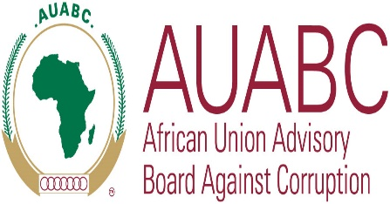
JOINT COMMUNIQUE
ADVOCACY MISSION OF THE AFRICAN UNION ADVISORY BOARD AGAINST CORRUPTION (AUABC) TO THE KINGDOM OF ESWATINI ON THE RATIFICATION OF THE AFRICAN UNION CONVENTION ON PREVENTING AND COMBATING CORRUPTION

4th November 2022. Mbabane, Kingdom of Eswatini. At the invitation of Ministry of Foreign Affairs and International Cooperation, the African Union Advisory Board Against Corruption (AUABC) led by the Chairperson, Hon Jean Louis Andriamifidy visited the Kingdom of Eswatini on an Advocacy Mission to encourage the Kingdom of Eswatini to ratify the African Union Convention on Preventing and Combating Corruption (AUCPCC).
The AUABC and the Government of the Kingdom of Eswatini both echoed the importance of dealing with corruption as it is a scourge that has slowed development in many African countries.
Through the week-long consultations, the Board and the Ministry of Justice recognized that the Kingdom of Eswatini has already put in place various measures aimed at promoting the fight against corruption and therefore joining the other State Parties to the AUCPCC will facilitate better cooperation within the framework of the Convention.
The Minister of Foreign Affairs and International Cooperation reassured the AUABC that the process of ratification is ongoing, and the instruments have been cleared at the necessary levels within the Executive arm of Government and awaits the relevant processes of approval by the Parliament. Both the AUABC and the Kingdom of Eswatini noted that there are no impediments to the ratification process and will work with Parliament to expedite the process.
The Kingdom of Eswatini has committed to ratify the Convention in time for the celebration of the 20th anniversary of the adoption of the African Union Convention on Preventing and Combating Corruption to be held on 11th July 2023.
The Chairperson of the Board, Hon Jean-Louis Andriamifidy appreciated the Kingdom of Eswatini for its commitment to the fight against corruption and for a warm welcome to the Board.
Done in Mbabane, the Kingdom of Eswatini on the 4th of November 2022.

