
MINISTRY OF EDUCATION AND TRAINING

sTRENGTHENING EDUCATION AND SKILLS TRAINING SYSTEMS TO SUPPORT HUMAN CAPITAL DEVELOPMENT IN ESWATINI
Project Number – P173151

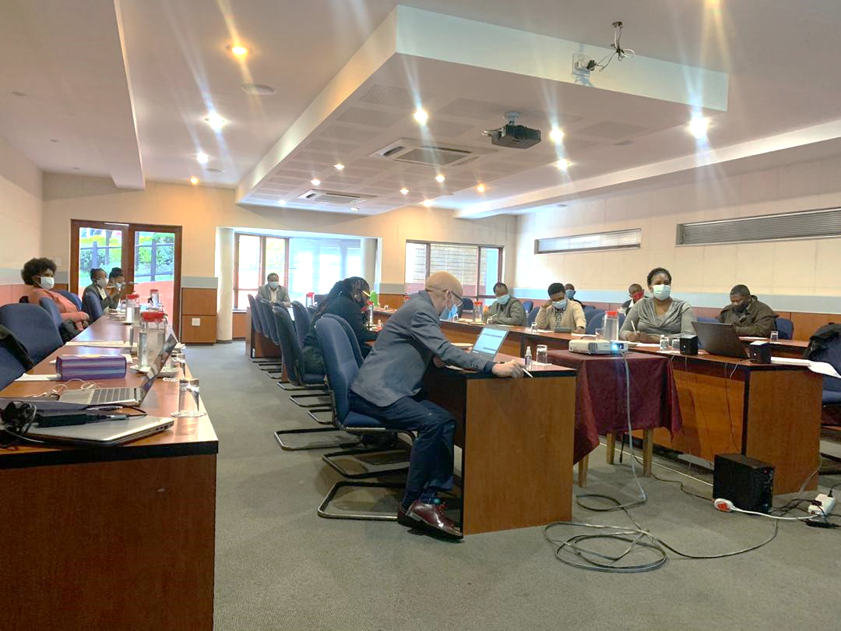
UPDATED STAKEHOLDER ENGAGEMENT PLAN (SEP)
SEP Update record
Review no. | Status | Date
1st | Final draft & disclosed | May 2021
2nd | Update draft | June, 2024

May 2021 January 2024

CONTENTS
1.INTRODUCTION 4
1.1 Background 4
1.2 Project Description 4
1.3 Project Development Objective 5
1.4 SEP Document Overview 5
1.5 SEP Objectives 6
1.2 SEP Principles for Effective Stakeholder Engagement 7
2. STAKEHOLDER IDENTIFICATION AND ANALYSIS 9
2.2 Project Stakeholders 9
2.2.1Project Affected Parties (PAPs) 9
2.2.2 Other Interested parties 10
2.2.3 Disadvantaged and Vulnerable People 10
2.3 Stakeholder Analysis 11
3.SUMMARY OF PREVIOUS STAKEHOLDER ENGAGEMENT ACTIVITIES 17
3.1 Initial Engagements 17
3.2 Summary of Stakeholders Engagements’ Feedback/outcomes 17
3.2.1 Component-specific outcomes 18
3.2.2 Outcomes from schools 18
3.3 SEP Consultancy Introductions 18
Annexures: Stakeholder workshop 20
4. STAKEHOLDER ENGAGEMENT PROGRAM 24
4.1 Stakeholder Engagement Methods (or techniques) 24
4.2 Project Information Disclosure 25
4.3 Methods to be used by MoET for Information Disclosure 25
4.4 Responsibilities and Resources for Implementing Stakeholder Engagement Activities 27
5. PROJECT MANAGEMENT STRUCTURE AND KEY RESPONSIBILITIES 27
5.1 Roles and Responsibilities for the SEP Implementation 28
6. GRIEVANCE REDRESS MECHANISM 29
6.4 Scope of Grievance Redress Mechanism 30
6.6 GRM at Project Level 32
6.7 GRM at Regional Level 34
6.8 GRM at National Level 35
6.9 Grievance Resolution Approach 36
6.10 Closure of Grievance 37
6.11 World Bank Grievance Handling Mechanism 37
6.12 Sexual exploitation and abuse and Sexual Harassment 37
6.13 Awareness raising and disclosure of the GRM 38
6.14 Grievance Records and Documentation 38
7. MONITORING AND REPORTING 39
7.1 Monitoring and Evaluation 39
7.2 Reporting Back to Stakeholders 40

List of Tables
Table 1: Project Stakeholders 17
Table 2: Engagement methods to be used by MoET ………………………………………….…. 22
Table 3: Strategy for information disclosure Component.……………………………..……..….23
Table 4: Stakeholder Engagement Process………… ……………………………………………..24
Table 5: Roles and Responsibilities for Implementation of the SEP…………………...……... 26
Table 6: E&S Budget ……………………..………………………………………………………....33

List of Figures
Figure 1: PIU Structure 38

Abbreviations and Acronyms
Acronym | Full Meaning
AIDS | Acquired Immuno-deficiency Syndrome
DPMO | Deputy Prime Minister Office
ECDE | Early Childhood Development and Education
EEA | Eswatini Environment Authority
ESF | Environmental and Social Framework
ESIA | Environmental and Social Impact Assessment
ESMF | Environmental and Social Management Framework
ESMP | Environmental and Social Management Plan
ESS | Environmental and Social Standards
GDP | Gross Domestic Product
GoE | Government of Eswatini
HCI | Human Capital Index
HIV | Human Immuno Virus
MICT | Information, Communication and technology
MEPD | Ministry of Economic Planning and Development
MoET | Ministry of Education and Training
MoF | Ministry of Finance
MOH | Ministry of Health
MSCYA | Ministry of Sports, Culture and Youth Affairs
MTAD | Ministry of Tinkhundla Administration and Development
NGOs | Non-governmental Organizations
PAP | Project Affected Parties
SNAT | Swaziland National Association of Teachers
STEM | Science, Technology, Engineering and Mathematics
TVET | Technical and Vocational Education Training
UNICEF | United Nations Children’s Fund
UNESCO | United Nations Education, Scientific and Culture organisation
UNFPA | United Nations Population Fund
WFP | World Food Programme

INTRODUCTION

1.1 Background
The Government of Eswatini, through the Ministry of Education and Training (MoET) is undertaking a project aimed at Strengthening Education and Skills Training Systems to Support Human Capital Development in Eswatini. The primary mandate of the Ministry of Education and Training is to provide access to relevant quality education at all levels and to all Eswatini citizens, taking into account all issues of efficacy, equity and special needs. The Ministry’s vision is ‘attainment of equality in educational opportunity for all pupils of school going age and adults irrespective of their socio-economic background, with the goal of enhancing their productive capacity, thus improving the quality of their lives’.

1.2 Project Description
The project became effective on 20 June 2023 after approval by the World Bank. Project implementation will take five years and end in 2027. The project has 3 components as listed below:
Component 1: Strengthen coordination and regulation of ECDE and improving access to quality in ECDE services
This component has the following subcomponents:
- System strengthening to improve ECDE service delivery
- Strengthening the quality of ECDE services in targeted centres
Component 2: Improving internal efficiency and quality in basic education
The following are subcomponents:
- Improve literacy and numeracy in the early grades
- Improve retention in secondary education
- Improve the quality of Mathematics and Science instruction in secondary education
Component 3: Project Management
- Capacity building and technical assistance
This component aims at strengthening key management capacities of the MoET, as the main implementer of the project, as well as builds the project-related required institutional capacity of regional and local education offices.

1.3 Project Development Objective
The Project Development Objective (PDO) is to improve access, completion and quality of basic education, skills, training and support services for girls, boys and the youth in the country.

1.4 SEP Document Overview
This document is an update of the initial Stakeholder Engagement Plan (SEP) that was disclosed in May 2021. The original SEP guided initial engagements made with stakeholders before commencement of project implementation. This version of the SEP is updated to highlight: i) Project Development Objective (PDO), project components and subcomponents, ii) incorporate stakeholders' engagements that took place after the disclosure of the preparation phase SEP in May 2021 as well as the Stakeholder Analysis, Stakeholder Engagement Process and Grievance Redress Mechanism (GRM).

1.5 SEP Objectives
The SEP defines a technically and culturally appropriate approach to consultation, disclosure and grievance redress. The overall objective of this SEP is to present a program for stakeholder engagement, including public information disclosure and consultation, throughout the project cycle. The SEP outlines the ways in which the project team will communicate with stakeholders and includes a mechanism by which people can raise concerns, provide feedback, or make complaints about project and any activities related to the project.

In addition, the SEP is a useful tool for managing communication between the project and its stakeholders. Stakeholder engagement involves interactions between identified groups of people to provide them with an opportunity to raise concerns and opinions. An effective stakeholder engagement aims at developing a “social licence” to operate and will depend on mutual trust, respect and transparent communication between MoET and its stakeholders. Other objectives of the SEP include the following:

- Understand the stakeholder engagement requirements of the Kingdom of Eswatini legislation.
- Provide guidance for stakeholder engagement to match the standards of International Best Practice.
- Assist MoET to identify project stakeholders affected in various ways and not their on the influence the Project and its activities;
- Help identify the most effective methods, timing and structures through which to share project information, and to ensure regular, accessible, transparent and appropriate consultation.
- Provides stakeholder engagement programme to be followed throughout the project phases and provides stakeholders with an opportunity to engage in project planning and design and its implementation.
- Establish formal grievance/resolution mechanisms.
- Define roles and responsibilities for the implementation of the SEP.
- Define reporting and monitoring measures to ensure the effectiveness of the SEP and periodical reviews of the SEP based on findings.

2. STAKEHOLDER IDENTIFICATION AND ANALYSIS
This section identifies stakeholders who will be engaged, informed and consulted about Project implementation through all its phases.
2.1 Key Principles of Stakeholder Engagements
To meet the best practice approaches, the Ministry of Education and Training will apply the following key principles for stakeholder engagement, which are aligned to the World Bank principles that ensure:
- Openness and life-cycle approach: targeted consultations for the project will be arranged during the preparation phase, carried out in an open manner, free of external manipulation, interference, coercion or intimidation.
- Informed participation and feedback: information will be provided to, and widely distributed among all stakeholders in an appropriate format; opportunities are provided for communicating stakeholders’ feedback, for analysing and addressing comments and concerns.
- Inclusiveness and sensitivity: stakeholder identification is undertaken to support better communication and build effective relationships. The participation process for the projects is inclusive. All stakeholders always encouraged to be involved in the consultation process.
An effective Stakeholder Engagement results in:
  - Managing costs: Effective engagement can help project proponents avoid costs, in terms of money and reputation.
  - Managing risk: Engagement helps project proponents and stakeholders to identify, prevent, and mitigate environmental and social impacts that can threaten project viability.
  - Enhancing reputation: By publicly recognising human rights and committing to environmental protection, project proponents involved in financing the project can boost their credibility and minimise risks.
  - Avoiding conflict: Understanding current and potential issues such as wider objectives of proposed project activities.
  - Improving national policy: Obtaining perceptions about a project, which can act as a catalyst for changes and improvements in practices and policies.
  - Identifying, monitoring and reporting on impacts: Understanding a project’s impact on stakeholders, evaluating and reporting back on mechanisms to address these impacts; and
  - Managing stakeholder expectations: Consultation also provides the opportunity for Government of Eswatini (GoE) to become aware of and manage stakeholder attitudes and expectations.

2.2 Project Stakeholders
For the purposes of effective and tailored engagement, stakeholders of the project were divided into the following three (3) categories namely Project Affected Parties (PAPs); Other Interested Parties (OIPs); and Disadvantaged and Vulnerable Groups.

2.2.1 Project Affected Parties (PAPs)
These include community members, households, community groups and others who are likely to be affected by project implementation activities in all the identified project sites. The MoET has identified PAPs mainly in the communities where schools under the project are located especially where project activities will be implemented. A list of PAPs’ as well as their interests and roles in the project are stated in Table 1 below. Project activities such as, installation of ICT infrastructure, fitting of burglar doors and engagements with communities on OVCs are likely to have environmental, social, security and safety risk on the communities. Therefore, constant communication on the progress and scheduling of project works is a crucial component of the project mainly to minimize adverse project implementation impacts and keep PAPs informed. On this aspect, the overarching implementation and monitoring of the stakeholder engagement plan will be the undertaken by the PIU’s E&S team. However, the direct responsibility of the SEP implementation falls on the Project Coordinator (PC) and the project E&S Specialists. Implementation of the project will bring about positive impacts to the communities where it will be implemented. The focus of the project will be on ensuring that all children are entitled to, and receive, a comprehensive package of services that will enable them to reach their full potential. Within these components, there are four crosscutting issues: gender inclusion, digital skills, and sustainability of interventions. Some elements of the project will also address the issues that arose from the COVID-19 pandemic, such as access to online learning opportunities for the poorest children, retaining students in school, and access to clean water, sanitation and hygiene in schools. The project will also focus on strengthening coordination and regulation at all levels of education, more specifically for ECDE.

2.2.2 Other Interested Parties
Other interested parties (OIPs) include those who may not be likely to be directly affected by project implementation but may have concerns ranging from project location, some of its characteristics, and its impacts, or other matters related to the broader public interest. OIPs may include regulators, government officials, the private sector, academia, workers’ unions, women’s organizations, civil society organizations, and cultural groups and others. Most importantly, the Project will continuously identify other interested parties’ interest and roles in the project’s design, implementation, and decision-making process. The MoET, through the PIU, has undertaken preliminary stakeholder identification exercise and has developed a list of all the actors that may affect the project design and outcome. A total of 42 stakeholders have been identified Table 1 below. The relationship between the MoET and the identified stakeholders will be nurtured continuously to create and maintain constructive engagements. Table 1 below shows the stakeholders identified to date and are listed according to their involvement, interest and influence in the SEP.

2.2.3 Disadvantaged and Vulnerable People
These groups of people may be disproportionately impacted or further disadvantaged by the project implementation as compared with any other groups due to their vulnerable status, and that may require special engagement efforts to ensure their equal representation in the consultation and decision-making process. Often these people lack the ability to deal with the impacts, the voice to express their concerns or understand of the impacts of the project. Therefore, it is important to ensure that awareness raising and stakeholder engagement with disadvantaged or vulnerable individuals or groups is conducted in appropriate and culturally sensitive manner to ensure full understanding of project activities and benefits. The vulnerability may stem from person’s origin, gender, age, health condition, economic deficiency and financial insecurity, disadvantaged status in the community (e.g. minorities or fringe groups), dependence on other individuals or natural resources, etc.

2.3 Stakeholder Analysis
The stakeholder analysis was conducted with an objective to establish each stakeholder’s interest on the Project as well as involvement of stakeholders in the project and their ability to influence the Project in all its phases. The purpose of the analysis and preliminary engagement was to determine and acquire opinions of the most influential stakeholders to help define the project at its preliminary stage. In Table 1 below is a general list of stakeholder groups identified and analysed as according to their involvement, level of interest, level influence, communication methods and frequency of communication.
Table 1: Project Stakeholders
Stakeholder  Group | Involvement | Interest | Influence | Communication method | frequency
Project Affected Parties
Ministry of Education and Training | Project identification, design and supervision /implementation | High | High | Project team meetings, email/ WhatsApp, progress reports | Weekly
Community members residing in project schools | Needs assessment | High | Medium | Project team meetings, email/ WhatsApp, progress reports | As per need
Schools | Curriculum development; needs assessment | Medium | Medium | Project team meetings, email/ WhatsApp, progress reports | As per need, Project milestones
School Children | Needs Assessment | High | Low | Project team meetings, email/ WhatsApp, progress reports | As per need
Other interested Parties
Deputy Prime Minister’s Office | Project implementation | High | High | Project team meetings, email/ WhatsApp, progress reports | Fortnightly
Ministry of Health | Project implementation | High | High | Project team meetings, email/ WhatsApp, progress reports | Fortnightly
Ministry of Sports, Culture and Youth Affairs | Project implementation | High | High | Project team meetings, email/ WhatsApp, progress reports | Fortnightly
Ministry of Tinkhundla Administration and Development | Project Implementation | Medium | Medium | Project team meetings, email, progress reports | Fortnightly
Ministry of ICT | Project implementation | High | High | Project team meetings, email, progress reports | As per need
Ministry of Labour and Social Security | Project implementation | High | High | Project team meetings, email, progress reports | As per need
Ministry of Natural Resources and Energy (DWA) | Project implementation | Medium | High | Project team meetings, email, progress reports | As per need
Ministry of Home Affairs | Project implementation | Medium | High | Project team meetings, email, progress reports | As per need
Ministry of Justice and Constitutional Affairs |  | Low | High | Project team meetings, email, progress reports | As per need
Teacher Training Institutions | Curriculum development; needs assessment | High | High | KII/FGD; Project leaflet | Project milestones
Teaching Service Commission | Needs assessment | High | High | KII/FGD | Project milestones
Regional Education Officers | Needs assessment | High | High | KII/FGD | Project milestones
Eswatini Principals Association | Needs assessment | High | High | KII/FGD | Project milestones
Swaziland National Association of Teachers | Needs assessment | High | High | KII/FGDs | Project milestones
Vocational Training Institutions | Curriculum development; needs assessment | High | Medium | KII/ FGD | Project milestones
Tertiary institutions | Curriculum development; needs assessment | Medium | Medium | KII/FGD; | Project milestones
Regional Administrators | Authority of Swazi Nation land | Medium | Medium | KII, Project leaflet | Project milestones
Tinkhundla | Umphakatsi representatives (Bucopho) | Medium | Medium | KII, Project leaflet | Project milestones
Municipalities | Regulation and licensing of land use; environmental health | Medium | Medium | KII, leaflet | Project milestones
Imiphakatsi | Authorisation of land use; community dispute resolution | Medium | Medium | FGD; leaflet | Project milestones
School committees | Needs assessment | High | Medium | FGDs, leaflet | Project milestones
Parents | Needs assessment | High | Medium | FGDs, leaflet | Project milestones
Student groups | Needs assessment | High | High | FGDs, Project leaflet | Project milestones
School auxiliary workers | Needs assessment | Medium | medium | FGDs, Project leaflet | Project milestones
Eswatini Communication Commission | Funding for procurement of appropriate access devices for learning | Medium | low | KIIs, Project leaflets | Project milestones
Donor agencies | Needs assessment, financing | High | High | KII, Project leaflet | Project milestones
Companies / businesses | Needs assessment, partnerships | High | Low | KII, Project leaflet | Project milestones
NGO | Needs assessment, partnerships | High | Low | KII, Project leaflet | Project milestones
Eswatini Revenue Authority | Funding for professional development of teachers  Financial support for learners with disabilities | low | low | KIIs, Project leaflets | Project milestones
MTN Eswatini  Swazi Mobile | Supply of specialised devises to enhance learning  Entrepreneur skills support (development of marketing strategies)  ’21 days of yellow care’ | low | low | KIIs, Project leaflets | Project milestones
Swaziland Council of Churches | Development of manuals for ECCE to early identification and intervention | Medium | low | KIIs, Project leaflets | Project milestones
General Public | Public support | Low | Low | Project website, Media briefings, road signs | Project milestones
Association of Transport Owners | Transporting students to and from school | Low | Low | Project website, Media briefings, road signs | Project milestones
Association of non-teaching school workers | Needs assessment | Medium | Low | KIIs, Project leaflets | Project milestones
EEA | Technical Assistance | Low | Low | Physical and phone calls | Project milestones
Disadvantaged and Vulnerable Groups
Eswatini Network on Education for All | - Financial support  - Material development  - Research  - Strategy planning | Medium | Medium | KII/FGD; Project leaflet | Project milestones
Federation of Persons with Disabilities (FODSWA) | Umbrella body for:  - Eswatini association for the visually impaired  - Eswatini association for the deaf  - Association for the physically disabled | High | High | KII/FGD; Project leaflet | Project milestones
Autism Eswatini | - Raising awareness  - Holistic approaches for parents and communities.  - Proposed resource centre | Medium | Medium | KII/FGD; Project leaflet | Project milestones
SWAAGA | - Raising awareness on Gender Based Violence, Sexual Abuse and Exploitation | Medium | Medium | KII/FGD; Project leaflet | Project milestones

3. SUMMARY OF PREVIOUS STAKEHOLDER ENGAGEMENT ACTIVITIES
This section gives a summary of stakeholders that were engaged at the initial stage of the project. It also presents the issues of engagements as well as a summary of key outcomes of the engagements.

3.1 Initial Engagements
Initial engagements were made with several stakeholders including Government Ministries and Departments, Government Parastatals, Curriculum and Teacher Training Institutions, TVET Institutions, Schools and Civil Society Organizations including NGOs (Table 1) shows list specific stakeholders that were engaged. Engagements were also made with the Consultant hired to develop some E&S instruments for the project. Engagements issues ranged from general information sharing and disclosure to those that were component specific. Initial stakeholder engagements were conducted by the Ministry’s planning office and the Consultant from various platforms such meetings (both face-to-face and virtual), workshops and phone conversations. Other issues included clarifications on roles of stakeholders; introduction of consultant to stakeholders as well as mapping stakeholders who will participate in project implementation especially in the various project components.

3.2 Summary of Stakeholders Engagements’ Feedback/outcomes
General feedback received from stakeholders pointed out to the need for environmentally safe and health conditions in facilities early child childhood education. Stakeholders also highlighted the need to link project outcomes to national development goals as well as address environmental sustainability. There are also component-specific outcomes as well as feedback from schools.

3.2.1 Component-specific outcomes
Component 1: ECDE
- Recognition of parents as crucial in the child learning especially with the increased reliance on home learning.
- Need to rehabilitate the identified early childhood education centres as they are currently in a dilapidated state due to lack of maintenance, vandalism and theft of teaching equipment
- Need for standard assessment tool for school readiness and mental health to assist special education.
Component 2: Basic Education
- Need for the MoET to develop a curriculum integrating ICT and use ICT as a teaching and learning tool supported by requisite hard and software as well as improved internet connectivity.

3.2.2 Outcomes from schools
Quite a number of outcomes were raised by schools. Included below are some of the key outcomes:
- Absence of physical classrooms for grade O in some schools children are taught either in a church or any spare room available.
- Inadequate and outdated reading materials for children.
- Low attendance rate to school especially among adolescents.
- Non-payment of school fees by parents.
- Lack of water supply and adequate food for children.
- Poor internet connectivity.
- Theft of computers and other school equipment
- Lack of laboratories that are specific for computer studies. Those available double up as exam prep rooms.
- Challenges of accessing school by teachers and children mainly due to poor road infrastructure.
Detailed Stakeholder engagement is included in Annex 8. In the same annexure there is also feedback on engagements conducted two months after project effectiveness

- STAKEHOLDER ENGAGEMENT PROGRAM
The MoET intends to utilize a variety of strategies to that the stakeholder engagement process is effective and meaningful. Since stakeholder engagement is a continuous process throughout the project phases appropriate engagement will be adopted tailor made to the different stakeholders and issues of engagement. The engagement strategy for every project phase or activity must meet general requirements on accessibility, i.e., shall be held at venues that are easily reachable and do not require a long commute, entrance fee or preliminary access authorization, cultural appropriateness (i.e. with due respect to the local customs and norms), and inclusiveness, i.e. engaging all segments of the local society, including disabled persons, the elderly, minorities, and other vulnerable individuals. Presented below are engagement strategies to be used by MoET in its consultations with stakeholders.

4.1 Stakeholder Engagement Methods (or techniques)
Table 2 below presents engagements methods the MoET will utilize for stakeholder engagement throughout the project cycle.
Table 2: Engagement methods to be used by MoET
Method | Objective
Community meetings  One-on-one (consultative) meetings  Letters  Email / WhatsApp | The majority of stakeholders engaged to date indicated that these are the most effective means to contact them.
Correspondences (Phone, Emails) | Distribute information through people’s phones and emails
Project website | Present project information and progress updates that stakeholders can access on a need basis.
Media Briefings | Disclose ESMF and other relevant project information to media houses.
Project brochure | Documentation and dissemination of accurate project information to stakeholders who may not have access to internet.
Community meetings | Organize meetings with the community on environmental and social issues

4.2 Project Information Disclosure
Information disclosure is crucial for the project mainly to ensure that appropriate project information pertaining to design and implementation is conveyed to the stakeholders and affected parties. Most importantly is to ensure that project activities particularly those that may bring about environmental and social risks and impacts are disclosed to stakeholders in a timely, understandable, accessible, and appropriate manner and format. The SEP will be disclosed after each updating process. The MoET will ensure that stakeholders have access to information listed in a timeframe that enables meaningful consultations with them. The disclosure and consultations activities will be informed by the following guiding principles:
- Consultations must be widely publicized particularly among the project affected stakeholders/communities, preferably 2 weeks prior to any meeting engagements.
- Allow non-technical information summary to be accessible prior to any event to ensure that people are informed of the assessment and conclusions before scheduled meetings.
- Location and timing of meetings must be designed to maximize stakeholder participation and availability.
- Information presented must be clear, and non-technical, and presented in both local language and mannerism.
- Facilitate the engagements in a manner that will allow stakeholders to raise their views and concerns.
- Provide answers/feedback on all issues raised at the meeting or later.

4.3 Methods to be used by MoET for Information Disclosure
Stakeholders engaged to date indicate that emails and WhatsApp are effective methods of contacting them or keeping them informed. This suggests that the creation of groups under each component would be effective. Other methods for disclosure are presented below and in Table 3 to cater for stakeholder groups that may prefer alternative methods.
- Notice boards: Posters, leaflets etc. May be placed in schools’ community halls, shops, clinics etc.
- Community meetings:
- Phone calls: etc.
Table 3: Strategy for information disclosure
Method | Objective
Email / WhatsApp | The majority of stakeholders engaged to date indicated that these are the most effective means to contact them.
Correspondences (Phone, Emails) | Distribute information to Government officials, NGOs, Local; Invite stakeholders to virtual meetings and follow-up
Project website | Present project information and progress updates that stakeholders can access on a need basis.
Media Briefings | Disclose ESMF and other relevant project information to media houses.
Project brochure | Documentation and dissemination of accurate project information to stakeholders who may not have access to internet.
Road signs | Share information on project activities (esp. construction / renovation)

4.4 Stakeholder Engagement Process
Below are engagement activities conducted from December 2020 to April 2024
Table 4: Stakeholder Engagement Process
Project phase | Stakeholder name/group | Issues of engagement | Methods of engagement |  | Location |  | Feedback
Before implementation/construction | Component 1,2 & 3 Engagements
Before implementation/construction | FODSWA/DWA | Project design | Virtual meeting |  | REO, Manzini |  | Need to for rehabilitation of classrooms
Before implementation/construction | DPMO | Project design | Virtual meeting |  | DPMO |  | all aspects of children’s welfare are with the DPMO
Before implementation/construction | MTAD | Project design | Virtual meeting |  | MTAD |  | Meeting agenda be sent in advance
Before implementation/construction | MoH | Project design | Virtual meeting |  | MoH |  | MoH has recently undergone the process of developing an ESMF and SEP and would be willing to advise MoET on any aspects
Before implementation/construction | Schools | Project design | Physical |  | Onsite |  | Inadequate teaching material, resources and infrastructure
Before implementation/construction | Emlalatini development Centre | Project design | Physical |  | Onsite |  | No support for ICT learning and teaching
Before implementation/construction | Principal’s Association | Project design | Physical |  | Onsite |  | Schools have no access to ICT, inadequate/dilapidated infrastructure
Before implementation/construction | Swaziland National Association of Teachers | Project design | Physical |  | Onsite |  | Request for more Grade 0 in public schools
Before implementation/construction | Gwamile VOCTIM | Project design | Physical |  | Onsite |  | Basic education is divorced from practical skills training
Before implementation/construction | Schools | Readiness for implementation | One on one |  | All Regions |  | Need for child sized toilets, floors fixing and proper classroom cabinet installations
 | Component 2.1 Engagements
During Implementation | Bigger INSET | Sensitization about the project and E&S aspects |  | Live meeting |  | TGH Manzini |  | Agreement on coordination of project activities with WB
During Implementation | NCC | Piloting and monitoring of project components |  | Live meeting |  | NCC Manzini |  | Please insert details
During Implementation | ECESWA | Sensitization and collaboration |  | Live meeting |  | ECESWA Offices |  | Discussed ECESWA’s role on the project and mapped a way forward
During Implementation | Panel Heads | Sensitization |  | Live meeting |  | MOET conference room |  | Sensitized about the project and their role
During Implementation | Component 2.2 Engagements
During Implementation | UNESWA In-service Department | Sensitization and functionality |  | Live meeting |  | UNESWA |  | Discussed role to be played by the UNESWA In-service department
During Implementation | NCC Evaluation Department | Project Monitoring |  | Live meeting |  | NCC Boardroom |  | Discussed how the component will monitor activities
During Implementation | Schools | To check Readiness |  | One on one |  | All Regions |  | Schools are ready for the project
During Implementation | Parents | Sensitization |  | Live meeting with Representatives |  | All Regions |  | Project awareness was discussed
During Implementation | Principals | To check Readiness |  | One on one |  | Pilot Schools |  | Discussed readiness of classrooms for the component
During Implementation | Component 3 Engagements
During Implementation | Parents, Parliament Portfolio Committee, Teachers and Learners | Project Stakeholder engagement system Sensitization |  | Live meeting |  | Mavuso Trade Centre |  | U-Report sensitization on using the SMS 8500 line

REPONSIBILITIES AND RESOURCES FOR IMPLEMENTING STAKEHOLDER ENGAGEMENT ACTIVITIES
This section presents the organizational structure and functions for the stakeholder for the management of the stakeholder engagement plan. It also presents the resources set aside for the implementation of the SEP.

5.1 Project Management Structure and Key Responsibilities
The Project is headed by a Project Steering Committee (PSC) consists of Principal Secretaries of the following ministries: MoET, DPMO, Ministry of Tinkhundla Administration and Development, MICT, MoH, MSYC, MoF and MEPD. The main responsibility of the PSC is to review progress under each component, provide technical guidance and support to all committee. The PSC meets quarterly.
There is also the Project Management Team (PMT) which comprises of the lead coordinating entities of the ECDE; Basic Education and TVET components will be responsible for hosting regular meetings with the respective implementing entities to: (i) agree on work plans/budgets/deliverables; (ii) monitor progress on achievement of deliverables; (iii) raise any concerns with implementation progress with the Project Steering Committee (PSC-described below); (iv) collate and submit progress reports to the PSC and the World Bank; (v) collate financial expenditure information for submission to the Project Implementation Unit. Members of the PMT are mostly officers in the MoET and members include: Director; Planning Officers; Chief inspector Primary; Chief inspector Secondary; Chief inspector Tertiary; Senior inspector ECDE; Under-secretary administration; Under-secretary schools’ management; EMS (monitoring and evaluation)
A Project Implementation Unit (PIU) was setup by the Ministry of Education and Training to lead the implementation of the project as well as the coordination of the Project. The PIU’s key responsibilities include (i) liaison and reporting to the MEPD and the World Bank; (ii) coordinating implementation, (iii) monitoring progress and reporting (with inputs from other implementing entities) under the project. Figure 1 below is the PIU structure as set up by the MoET. However, there are several other Ministries involved in the implementation of the project under different components and sub- components of the Project. The PIU comprises of the under listed and excludes those PIU members seconded from Ministry’s departments.
- Project Coordinator (PC)
- Personal Assistant
- Financial Management (FM) specialist
- Accountant
- Procurement Specialist
- Procurement assistant (depending on the amount and frequency of procurement related activities for goods, services and civil works)
- Environmental and Social (E&S) Specialist
- Monitoring and Evaluation (M&E) Specialist
- Education Specialist

The PIU will consolidate reports for sharing during the Project Steering Committee meetings held quarterly.

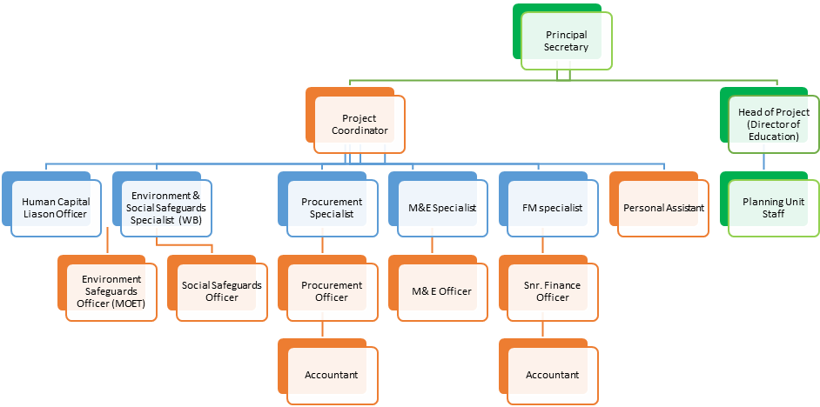
Figure 1: PIU Structure

5.1 Roles and Responsibilities for the SEP Implementation
The Project E&S Specialist(s) is/are responsible for overseeing the implementation of the SEP. The specialist (s) will liaise with the Project Coordinator who is responsible for the overall program management of various programs and the monitoring, evaluation and reporting functions to report on progress and challenges against the plan. Table 5 below the specific roles and responsibilities of PIU members with respect to the implementation of the SEP.
Table 5: Roles and Responsibilities for Implementation of the SEP
PIU Position | Responsibilities
Project Coordinator | - Overall coordination of components leaders  - Execute SEP budget.  - Ensure relevant stakeholders are engaged at all phases of the project.  - Monitor performance indicators and reporting on them quarterly to the World Bank.  - Facilitate and coordinate with relevant stakeholders to ensure maximum efficiency in understanding the context and obtaining required data and information.  - Support all stakeholder engagement events.  - Participate in the stakeholder meetings (Time permits).
E&S Specialists | - Monitoring and information gathering, including addressing grievances  - Develop, implement, and monitor all stakeholder engagement strategies/plans for the Project.  - Manage the Grievance Redress Mechanism.  - Prepare documents related to the management of intensive stakeholder engagement.  - Liaise with the project coordinator to ensure that stakeholder engagement requirements/protocols are understood and followed.  - Monitor the progress of actions against the identified timeline which includes monitoring the communication and meetings that are held.  - Report to stakeholders including development partners on the progress including stakeholder engagement activities.  - Submit performance indicators to the Project Coordinator.  - Facilitate and coordinate with relevant stakeholders to ensure maximum efficiency in understanding the context and obtaining required data and information.  - Ensure stakeholders engagement and provide the needed support in this regard starting with developing the comprehensive SEP.  - Conduct all stakeholder engagement events.  - Ensure disclosure of information.  - Conduct stakeholder meetings and compile meeting minutes of all engagements.  - Maintain stakeholder database.
M & E | - Undertake citizens engagement survey  - Monitor performance indicators and reporting and liaise with the Project Coordinator and E&S Officer(s) for reporting purposes  - Maintain stakeholder engagement database

5.3 SEP Implementation Resources
The SEP will be implemented using financial resources allocated under each project component. The different components have their own budget for stakeholder engagement. The E&S team will accompany components where a need arises.
Table 6 Stakeholder Engagement Budget
Activity code | Category of Expenditure | Expenditure description | Project Duration
3.18 | Technical Assistance | Capacity Building and training for PSU and Ministry Staff, including development of site specific ESMPs and GRM Posters, leaflets and signposts | $84,000.00
3.19 | Toll- Free | Establishment of Toll-Free line and related subscriptions Setting up of GRM | $170, 000.00
3.25 | ICT Equipment | Tablets to be used for data collection by M&E and E&S | $43,000.00
 | Awareness Raising | Consultations to raise awareness on issues pertaining GBV and SEA/SH including project implantation disclosure and updates to stakeholders | $ 1 111.00

GRIEVANCE REDRESS MECHANISM
  - Introduction
Grievances raised by stakeholders related to project implementation need to be managed and resolved through a transparent process that is readily accessible and acceptable to all affected stakeholders and interested parties, at no cost and without retribution. The grievance redress mechanism (GRM) developed should be proportionate to the scale of impacts and risks presented by a project, and beneficial for both the proponent/operator and all stakeholders. The GRM must not impede access to other available judicial or administrative remedies
  - Objectives of the GRM
The project’s Grievance Redress Mechanism (GRM) is developed mainly to assist in the resolution of complaints and grievances in a timely, effective and efficient manner that satisfies all parties involved. Specifically, it provides a transparent and credible process for fair, effective and lasting outcomes. It also builds trust and cooperation as an integral component of broader community consultation that facilitates corrective actions. Specific objectives of the GRM include the following:
- Provides affected people with avenues for making a complaint or resolving any dispute that may arise during the course of the implementation of projects.
- Ensures that appropriate and mutually acceptable redress actions are identified and implemented to the satisfaction of complainants; and
- Avoids the need to resort to judicial proceedings.
A functioning GRM must assist the project through the following key functions:
- Record, categorize and prioritize the grievances.
- Settle the grievances via consultation with all stakeholders (and inform those stakeholders of the solutions)
- Forward any unresolved cases to the relevant authority.
  - Grievance Redress Mechanism Principles
The GRM must adhere to the following principles:
- Fairness. Grievances are treated confidentially, assessed impartially and handled transparently.
- Objectiveness and independence. The Grievance Redress Mechanism operates independently of all interested parties in order to guarantee fair, objective, and impartial treatment to each case. The GRM officials have adequate means and powers to investigate grievances (e.g., interview witnesses, access records).
- Simplicity and accessibility. Procedures to file grievances and seek action are simple enough that project affected peoples (PAPs) and beneficiaries can easily understand them. PAPs and beneficiaries have a range of contact options including, a telephone number (Toll-Free), an e-mail address, and a postal address. The GRM is accessible to all stakeholders, irrespective of the remoteness of the area they live in, the language they speak, and their level of education or income. The GRM does not use complex processes that create confusion or anxiety (such as only accepting grievances on official-looking standard forms or through grievance boxes in government offices).
- Responsiveness and efficiency. The GRM is designed to be responsive to the needs of all complainants. Accordingly, officials handling grievances are trained to take effective action upon, and respond quickly to, grievances and suggestions.
- Speed and proportionality. All grievances, simple or complex, are addressed and resolved as quickly as possible. The action taken on the grievance or suggestion is swift, decisive, and constructive.
- Participatory and social inclusion. A wide range of project-affected people, community members, members of vulnerable groups, project implementers, civil society, and the media are encouraged to bring grievances and comments to the attention of project authorities. Special attention is given to ensure that poor people and marginalized groups, including those with special needs, are able to access the GRM.

6.4 Scope of Grievance Redress Mechanism
The GRM will cover grievances raised in relation to the following.
- All concerns raised in relation to the implementation of any projects and programs coordinated by the PSU.
- All concerns raised in relation to occupational, community health and safety risks in project implementation areas
- Adverse environmental and social impacts in relation to implementation of Project funded activities and programs.
  - Structure of the Grievance Redress Mechanism
The GRM works within existing legal and cultural frameworks. It is recognized that the grievance mechanism would comprise community level, project level, regional level and National Eswatini Judiciary levels of redress mechanisms
6.5.1 Grievance Redress Mechanism at Community Level
Local communities on SNL have existing traditional and cultural grievance redress mechanisms. It is expected that some disputes at the community level may be resolved using these mechanisms, without the involvement of the contractor(s), and or Government representatives at local and national level. This has to do primarily with matters involving the extended family members as well as disputes that include differences between households especially over land, or boundaries, even on issues triggered indirectly by the Project. The GRM will involve the traditional leadership/structures and families concerned as per existing traditional dispute resolution mechanisms. If matters are not resolved adequately within 14 days, the parties, following established procedures, move the process to the national court (Ndabazabantu) within the Regional Administrator’s office. If an amicable settlement is not reached within 7 days the matter is referred to the ultimate level for community grievance usually relevant King’s Councils, where the ruling made is final. It is worth noting that issues reaching this level take too long to finalize and are outside the scope of the PIU, thus the PIU will try by all means to handle cases and manage the project through using the steps mentioned in 6.5.2 below.
Project related grievances resolved through traditional mechanisms will be duly reported to the MoET by the PIU’s E&S Specialists and will be included in the Environmental and Social Risk Management Specialist (ESRMS)’s routine project reporting. The points of access for grievances will be shared as part of consultation with all PAPs and through broader community consultation. These include the Toll-Free line, email and SMS’s.
Other grievances, not culture-related will be logged by the E&S Specialists and will send acknowledgement to complainants within 24 hours after receiving the grievance, unless it is logged anonymously. If the grievance is registered anonymously, it will be automatically referred to the head of the Project Support Unit. If, within 2 days, the matter is not resolved the E&S Specialist will refer the grievance to the Community Grievance Committee as constituted within 3 weeks. The aim is to resolve all grievances within four weeks. Any grievance which is not resolved within that timeframe will be referred to the Project level and be reported in detail in monthly Project Support Unit reports and quarterly reports to the World Bank.
In principle, where a complaint is related to Swazi Nation Land, the Environmental and Social Specialist will seek to mediate the situation through the community liaison officers (CLO) and will give feedback within 2 weeks.
The community level GRC will constitute the following members:
- Bucopho- Chairperson
- Community Rep
- Bandlancane Rep
- Rural Health Motivator
- School Rep/Principal
- School Committee Rep
- E&S
Uptake Channels at community level
The grievances can be communicated through the following channels:
- Rural Health Motivator
- School Principal
- Royal Kraal Secretary
- Bucopho
- GRM contacts displayed in community halls, shops, etc
Grievances received from PAPs on Title Deed Land or land on 99-year leasehold would be lodged directly to the PIU’s E&S Specialists through project hotline, emails, phone calls, writing or in person. Upon receiving the grievances, the E&S Specialists would send acknowledgements to PAPs within 24 hours after receiving the grievances and refer the matter to the PC to determine appropriate and available resolution structures. In urban areas, the local authorities in the country have GRM structures in existence to preside over the grievances.

6.5.2 GRM at Project Level
When a grievance is logged at the project level, the Environmental and Social Risk Management Specialist shall acknowledge and register the complaint within 24 hours. If the complaint is logged anonymously, it will be automatically referred to the Project Coordinator. Upon registration, the Environmental and Social Specialist will refer the issue for resolution to the Project Level Grievance Redress Committee within 7days. The aim is to resolve all grievances within 2 weeks.
A Complaints Register will be maintained by the ESRMS, who will log the following:
- Details and nature of the complaint.
- The complainant’s name and their contact details;
- Date.
- Corrective actions taken in response to the complaint. This information will be included in project progress reports. The project level process can only act within its appropriate level of authority and where appropriate, complaints will be referred on to the relevant authority which is the Principal Secretary
The project’s GRC will constitute the following members:
- The Project Coordinator (Convenor)
- Environmental and Social Specialist(s)
- Component Heads
- PAP Representative (as a need deems appropriate)
All GRM processes will be handled by the E&S Specialists as they are person responsible for the GRM. The E&S specialist shall ensure that the following are undertaken:
- Access of GRM
Ensured that multiple grievance uptake channels are available to the PAPs and all other stakeholders where prior stakeholders are made aware of the GRM and methods to lodge a grievance. In this GRM complaints can be lodged through the Toll-free line, email, schools’ offices, complaints boxes on project sites, the E&S, school or project site office and this should be shared with the E&S within 48 hours.

- Register
Register complaints and assign reference numbers (with option of anonymity) and keep a log of resolution process and provide summary of issues to project Engineer monthly.
Assess and Respond
Assess the nature of the grievances and refer them to relevant structures resolution. The complaint should be acknowledged within 2 working days, with the reference number, outline resolution process and expected timeframe.
Resolve
Provide PAPs with proposed resolution/mediation within 14 days. The ESRMS should then complete the documentation of complaint and resolution within 21 days of registration of complaint.
Monitor and follow up
Meet with PAP to verify the agreed plan for resolution and assess mitigation progress. This should be done within 28 days of registration of grievance. The PAPs shall be visited by the ESRMS if implementation of remedial actions stretches longer than the specified period.
Grievances may be lodged directly to the school or project site with the principal’s office or through a comments and suggestion box to be installed in each site. Grievances can also be logged in the regional education office directly. This will then be passed to the Environment and Social specialist. When a grievance is logged, the Environmental and Social Risk Management Specialist should acknowledge the complaint, unless the issue is logged anonymously, then it will be automatically referred to the Project Coordinator. Upon registration, the Environmental and Social Specialist will refer the issue for resolution or mediation to the Project Coordinator. The aim is to resolve all grievances within 2 weeks. Any grievance which is not resolved within that timeframe will be reported in detail in monthly Project management reports. All other grievances will be aggregated to track trends for managerial response.
A Complaints Register will be maintained by the Environmental and Social Specialist, who will log the:
- Details and nature of the complaint.
- The complainant’s name and their contact details.
- The date of complaint

6.5.3 GRM at Regional Level
The Regional level of the GRM seeks to resolve grievances and complaints that cannot be resolved at project level. A Regional GRC will be constituted comprising of the following:
- Regional Secretary _Chairperson
- Constituency headman (for rural communities)
- Regional Education Officer (REO)
- Project Coordinator
- Environmental and Social Risk Management Specialist
- MoET Communications Officer
Regional level GRM should work at resolving issues within 14 days from the date of receiving grievance from the project level GRM. The chairperson of the GRC, through the ESRMS, shall communicate the committee’s decision in writing to the concerned PAP within 5 days after issue has been resolved. If the grievance is not resolved or parties are not satisfied with the outcome of the resolution process, the ESRMS will refer the matter to the national level.

6.5.4 GRM at National Level
A Grievance Committee (GC) led by the Principal Secretary of the MoET will be set up mainly to resolve complaints received from the Regional level and will include the following persons:
- Principal Secretary- MoET
- Principal Secretary-Finance
- Director Economic Planning and Development
- Project Coordinator
This will follow the process outlined in Table 7 below.

Table 7: PIU Grievance mechanism
Step | Process
1 | The Aggrieved Party (AP) will take his/her grievance through the MoET toll free line 9664 (Currently being attended to), or email to the E&S Specialists at grievance@moet-wbproject.org.sz (under development) or in person at the MoET office. A WhatsApp number and SMS (under development) will also be used to report grievances.  The complaint will then be passed by the Call Centre Agents and other prescribed channels to the Environmental & Social Specialist (of the PIU) within 24 hours.
2 | The Environmental & Social Specialist logs the grievance and acknowledges receipt to the complainant within 24 hours including communicating the timeline within which resolution is expected, i.e. 14 days and not more than one month in case additional investigation/research is needed. As a minimum the following information shall be recorded:  - Case number  - Complainant’s name and contact details  - Date and time of complaint  - Description/statement of the grievance including where it happened, date and the Contractor staff complained against if applicable  - Date complaint is referred to the PIU by toll free line, email or in person.  The information below shall be shared by the PIU with stakeholders, during the next round of consultations and will include more details on the process of making a grievance and what to expect in terms of procedures and timelines:  - Toll Free No (9664),  - Email address (grievance@moet-wbproject.org.sz)  - Office address: Ministry of Education and Training Building Hospital Hill Road,  - Postal Address: P. O. Box 39 Mbabane, Eswatini  - Telephone Numbers: (+268) 24042491/ 24045750/ 24043307,
3 | The Environmental & Social Specialists then refer the complaint to the relevant Grievance committee (GC) within 24 hours after it has been received. Resolution of the grievance must be reached within 14 days from the date the grievance was received. The timeframe can extend beyond 14 days depending on the nature of the dispute and type of follow up required but must not exceed 30 days. The expectant timeframe will be communicated by the PIU to the complainant and the reasons for the extra days beyond the standard 14 days will be recorded in a grievance log.
4 | If the GC determines that additional research / investigation is needed beyond 30 days, the PIU will inform the complainant that additional time is required to work on the grievance, not more than 6 weeks from when the complaint was first made.
5 | In exceptional circumstances, if more than 6 weeks is required, the PIU will record such in detail and share with the PC and World bank for prior approval before the extension of time can be granted. Moreover the extension details will also be reflected in the PIU’s bi-annual reports and M&E reports.
6 | The complainant will be informed of the outcome immediately and at the latest within 5 days of the decision.
7 | If the complainant is not satisfied, or the matter is not resolved, the complainant will be notified of his/her right to appeal the decision of the PIU through the national appeal processes.

The PIU GM and the GC are required to follow the steps for resolution of grievances:
- The GC shall convene as per necessity (but at least once a month) and shall include a minimum of 5 members being the Environmental & Social Specialist, Project coordinator, Head of project, Human Capital Liaison Officer and a Civic /NGO representative.
- Special provisions will be made for any complaints of a confidential nature and in the case of complaints related to sexual exploitation and abuse (SEA) and sexual harassment (SH), procedures as laid out in the SEA/SH action plan to be prepared will be followed.

6.6 Grievance Resolution Approach
The following steps shall be performed in a timely manner to avoid delaying resolution of a grievance:
- Obtain and document as much information as possible from the complainant to gain a first-hand understanding of the grievance (For handling grievances relating to SEA and SH, please refer to SEA/SH action plan to be prepared).
- Undertake a site visit, if required, to clarify the parties and issues involved. Gather the views of other stakeholders.
- Determine whether the grievance is legitimate/sound. Inform the complainant of the expected time frame for resolution of the grievance.
- Enter the findings of the investigation in the grievance database.
The results of the investigation of non-sensitive complaints should be publicized.

6.7 Closure of Grievance
A grievance will be considered “resolved” or “closed” when a resolution satisfactory to both parties has been reached, and after corrective measures have been successfully implemented. When a proposed solution is agreed upon between the Project and the complainant, the time needed to implement it will depend on the nature of the solution. However, the actions to implement this solution will be undertaken within one month of the grievance being logged and will be tracked until completion. Once the solution is under implementation or has been implemented to the satisfaction of the complainant, a complaint close out form will be signed by both parties (PC or its representative and the complainant), stating that the complainant considers that his/her grievance is closed. The grievance then, will be archived in the Project Grievance database. In certain situations, however, the Project may” close” a grievance even if the complainant is not satisfied with the outcome. This could be the case, for example, if the complainant is unable to substantiate a grievance, or it is obviously speculative or fraudulent. In such situations, the Project’s efforts to investigate the grievance and to arrive at a conclusion will be well documented and the complainant advised of the situation. MoH will not dismiss grievances based on a cursory review and close them unless the complainant has been notified and had the opportunity to provide supplementary information or evidence.

6.8 World Bank Grievance Redress Services
The World Bank Grievance Redress Services (GRS) is available to PAPs and individuals who may wish to lodge their grievances directly to the Bank. The contacts below allow complainants to send their grievances to the Bank’s Grievance Redress Service (GRS). A complaint can be submitted to the Bank’s GRS through the following channels:
- Email: grievances@worldbank.org
- Fax: +1.202.614.7313
- Mail: The World Bank, Grievance Redress Service, MSN MC10-1018, 1818 H Street,
- Northwest, Washington, DC 20433, USA.

6.9 Sexual exploitation and abuse and Sexual Harassment
Other measures to handle sensitive and confidential complaints, including those related to Sexual Exploitation and Abuse/Harassment (SEA/SH), will be identified in the SEA/SH Action Plan which will be project specific and will be developed by the contractor during project implementation. With respect to SEA/SH related complaints, special procedures will be adopted in order to ensure anonymity and referral procedures to associated NGOs who are experienced in handling GBV cases will be set up. If the matter remains unresolved, or complainant is not satisfied with the outcome at the project level, the head of the GM, will then refer the matter to the MoET for a resolution. Project Affected Parties (PAPs) have the option to take their respective case/s directly to the established legal system as provided by Eswatini law.

6.10 Awareness raising and disclosure of the GRM
Awareness raising and disclosure of the GRM will be provided in an accessible format. Communities and potentially affected persons will be advised of the GM in the early stages of engagement on the project, and be made aware of:
• The potential impacts of the project and how these impacts are to be minimized.
• How they can access the GRM (i.e. key people and complaint forms);
• Who to speak to and how to make a complaint.
• The timeframes for each stage of the process.
• The GM being confidential, responsive and transparent; and
• Alternative avenues of dispute resolution where conflicts of interest exist.

6.11 Grievance Records and Documentation
A PIU grievance log will be maintained (See Annex 2). The PIU Grievance log at a minimum will record the following information:
- Individual case number
- Complainant’s name and contact details (unless the complaint has been submitted anonymously)
- Date and time of complaint
- Date complaint was sent by Hotline to PIU (standard is within 24 hours complaint being received by Hotline)
- Date complaint was logged by PIU
- Date acknowledgement was sent to complainant by PIU
- Time estimated to address (based on timelines set out in stage 1 and stage 2)
- Description/statement of the grievance including where it happened, date and the Contractor staff complained against if applicable
- Details of proposed resolution, including person(s) who will be responsible for authorizing and implementing any corrective actions that are part of the proposed resolution OR Details of it being sent to Stage 2
- Date when proposed resolution was communicated to the complainant (unless anonymous) Or Date of when it was referred to Stage 2
- Details of whether the complainant was satisfied with the resolution, whether the complaint can be closed out
- Date of when the complaint is closed
- Date when the resolution is implemented (if any).

- MONITORING AND REPORTING

  - Monitoring and Evaluation
Monitoring and evaluation of the stakeholder engagement process is considered vital to ensure MoET can respond to identified issues and alter the schedule and nature of engagement activities to make them more effective. Adherence to the following characteristics/commitments/activities will assist in achieving:
- Successful engagement.
- Sufficient resources to undertake the engagement.
- Inclusivity (inclusion of key groups) of interactions with stakeholders.
- Promotion of stakeholder involvement.
- Sense of trust in MoET shown by all stakeholders.
- Clearly defined approaches; and
- Transparency in all activities.

Monitoring of the stakeholder engagement process allows the efficacy of the process to be evaluated. Specifically, by identifying key performance indicators that reflect the objectives of the SEP and the specific actions and timings, it is possible to both monitor and evaluate the process undertaken. Two distinct but related monitoring activities, in terms of timing, will be implemented:
- During the engagement activities: short-term monitoring to allow for adjustments/improvements to be made during engagement; and
- Following completion of all engagement activities: review of outputs at the end of engagement to evaluate the effectiveness of the SEP as implemented.
During engagement with stakeholders the engagement team will assess meetings using a feedback evaluation form or asking questions to participants, depending on the stakeholder group, to ensure that messages are being conveyed clearly. The engagement team will also conduct debriefing sessions while in the field. This assesses whether the required outcomes of the stakeholder engagement process are being achieved and provide the opportunity to amend the process where necessary.
These findings will be recorded in both monthly and quarterly updates; the quarterly updates are to be shared with the World Bank team,
The Stakeholder engagement tools for M&E will include:
- Stakeholder database.
- Issues Log or Issues and Response table; and
- Meeting records of all consultations held.
Moreover, the tool can be used to manage on-going Project issues, and for stakeholder identification and analysis processes.
The identification of project related impacts and concerns is a key element of stakeholder engagement that will occur over the complete project life cycle. As such, the identification of new concerns and impacts as the ESMF/ESMP and project progresses will serve as an overall indicator for the MoET of the stakeholder engagement process.
Performance of stakeholder engagement will be assessed based on the extent to which the engagement activities and outputs meet those outlined in the SEP. In assessing performance, the following should be considered:
- Materials disseminated: types, frequency, and location.
- Place and time of formal engagement events and level of participation including specific stakeholder groups (e.g., educationalists; women, youth, community leaders);
- Number of people attending public or formal meetings.
- Number of comments received on specific issues, type of stakeholder and details of feedback provided.
- Numbers and type of stakeholders who meet the Project team by mail, telephone and any other means of communication.
- Meeting minutes, attendance registers and photographic evidence.
- Comments received by government authorities, community leaders and other parties and passed to the Project.
- Numbers and type of feedback and/or grievances and the nature and timing of their resolution; and the extent to which feedback and comments have been addressed and have led to corrective actions being implemented.
  - Reporting Back to Stakeholders
The SEP will be periodically revised and updated as necessary during project implementation in order to ensure that the information presented herein is consistent and is the most recent, and that the identified methods of engagement remain appropriate and effective in relation to the project context and specific phases of the development. Any major changes to the project related activities and to its schedule will be duly reflected in the SEP. Specific dates/requirements for SEP updates will be agreed upon by the PIU and World Bank team.
Regular, preferably monthly summaries and internal reports on public grievances, enquiries and related incidents, together with the status of implementation of associated corrective/preventative actions will be collated by responsible staff and referred to the senior management of the project. The monthly summaries will provide a mechanism for assessing both the number and the nature of complaints and requests for information, along with the Project’s ability to address those in an effective manner. Mandatory quarterly updates from PIU to the world bank will also include an update on all activities conducted, issues raised, challenges etc. under the SEP as well as under the Grievance mechanism.
Finally, information on public engagement activities undertaken by the Project during the year may be conveyed to the stakeholders through publication of a standalone annual report on project’s interaction with the stakeholders. Further details will be outlined in the updated SEP, to be prepared within the first quarter of project effectiveness, specific date will be agreed upon between PIU and World Bank team at a later stage.
Periodic feedback from stakeholders will be used to update the SEP from time to time, dates will be agreed by PIU and World Bank team.

Annex 1: Engagement record checklist
Date of engagement
Location of engagement
Form of engagement (e.g. KII / FGD /community
# of participants: | Profile of stakeholder(s):
List of documents disclosed
Summary of main points and concerns raised:

Summary of how stakeholders’ concerns were responded to and taken into account:

Annex 2 GRM form
GRIEVANCE/INQUIRY RECORD

Instructions: This form is to be completed by staff receiving the inquiry or grievance and sent to the Project Implementation Unit at the Ministry of Education and Training. Attach any supporting documentation/letters as relevant.
Date Grievance Received: |  |  | Name of Staff Completing Form:
Place Grievance Received:

Mode of Filing Inquiry or Grievance (check √):

□ In person □ Telephone □ E-mail □ Toll free no □ Website

□ Grievance/Suggestion box □ Community meeting □ Public consultation □ Other ______________

Name of Person Raising Grievance: (information is optional and always treated as confidential)

Gender: □ Male □ Female □ other
Address or contact information for Person Raising Grievance: (information is optional and confidential)

Location where grievance/problem occurred [write in]
National: | Inkhundla: | Chiefdom: |  | Others: | Others:
Brief Description of Grievance or Inquiry: (Provide as much detail and facts as possible)

Who should handle and follow up on the grievance?
Progress in resolving the grievance (e.g., answered, being resolved, settled):
Other Comments:

Annex 3 Acknowledgement form
GRIEVANCE ACKNOWLEDGEMENT

Instructions: This form is to be completed by the Project Implementation unit and mailed or delivered to the complainant.
Date Grievance Received: | Tracking Number: | Grievance Category:
Grievance Received (check √):
□ National □ inkhundla □ Chiefdom
Mode of Filing Inquiry or Grievance (check √):

□ In person □ Telephone □ E-mail □ Phone Text Message □ Website

□ Grievance/Suggestion box □ Community meeting □ Public consultation □ Other ______________

Name of Person Raising Grievance: (information is optional and always treated as confidential)

Gender: □ Male □ Female □ other
Contact information for the Person Raising Grievance: (information is optional and confidential)

Email:
Phone:
Address:

Annex 4: Minutes of Stakeholder meetings

Introduction Meeting Minutes

Date: Monday, 07 December 2020

Venue: Ministry of Education and Training Conference Room, Ground Floor

Time: 2.00 pm

Attendees

FULL NAMES | DESIGNATION | EMAIL/CONTACT
Mgcibelo L. Tsela | SI-ICT | lmktsela@gmail.com
Vusi Simelane | ACT-CIP | vusisim@gmail.com
Sindisiwe Nxumalo | Sociologist MTK Sustainable Technologies | sindinx69@gmail.com
Thobile Khumalo | Environmentalist MTK Sustainable Technologies | thobie_khumalo@yahoo.ca/tkhumalo@mtkivest.com
Nonhlanhla Shongwe | Snr Planning Officer | shongwen81@gmail.com
Martha S. Shongwe | CIS | ortizmartha88@yahoo.com
Lindiwe Dlamini | ETGPS Director | directoretgps@gmail.com
Dr N.L Dlamini | Director | lenhledlamini2003@yahoo.co.uk
Gwen Simelane | S.I. ECCDE | gwensimelane@yahoo.com
Fikile Mdluli | MSET-CJ-T | fcmdluli@gmailcom
The attendance Register is attached.
Agenda:
- Introduction of Consultants to Project Management team
- Remarks by chairperson
- Discussions on expectations
- Way forward and closing

- Introductions

Mr Gwebu introduced MTK Sustainable Technologies (Pty) Ltd team to the Ministry of Education and Training project management team. He also appreciated the attendance by Ministry officials at such short notice. He indicated that the work of the consultants in developing an ESMF is part of the preparatory stage of the project on strengthening Education and skills training systems to support human Capital development in Eswatini. He indicated that the requirements that need to be fulfilled for the project to be submitted for review by the World Bank are:
- The Environmental and Social Management Framework (ESMF)
- Stakeholder Engagement Plan (SEP)
- Resettlement Action Plan (RAP)
- Environmental and Social Commitment Plan (ESCP)
Since resettlement is not anticipated for the project, the RAP was not seen to be necessary at this point. However, general guidelines will need to be presented in case there is a need for relocate structures during the specific projects. The ESCP will be done in-house by the MOET. He also indicated that the project timelines are very tight. He appealed with the team to cooperate with the consultants.

Remarks by Project team chairperson

The chairperson welcomed the consultants and expressed appreciation on the work that Mr. Gwebu and Ms. Shongwe had done in moving speedily with the project to the point of appointing consultants. She pledged support from her office and the team She is working with. She then introduced the project management team, which consists of leaders from the different clusters under the 4 components of the project.

Discussions on Expectations

Mrs T Khumalo from MTK Sustainable Technologies expressed appreciation for the opportunity that has been given the company in carrying out the assignment. She indicated that reports and documents that they had requested from the Ministry have been received and are very helpful. She requested that the project team gives an indication on the types areas that may be potential project sites. She stated that for the ESMF to be relevant, there should be an idea of the general areas that will be considered for the project.

Ms. Sindi Nxumalo, who is also part of the consultant team outlined the importance of stakeholder engagement to inclusive, culturally relevant and indicated that the SEP is a living documents that keeps being updated as more stakeholders are discovered. She indicated that the main approach to be used in this assignment will be Key informant interviews and focus group discussions. There will not be a detailed survey.

Ms. Dlamini from MOET team wanted clarification on the involvement of external stakeholders that they work with like UNICEF.
Ms Nxumalo indicated that the information will be sourced from the project team on the role that those stakeholders play in this project. The consultants will then assist in determining their level of interest and influence in the project.
The project team also indicated that the priority stakeholders to be engaged as they are partners in the project are:
- Ministry of Health
- Deputy Prime Minister’s Office
- Ministry of Sports, Culture and Youth Affairs
- Ministry of Tinkhundla Administration and Development
The consultants will have to be introduced to these stakeholders as soon as possible.

Mr. Simelane requested a template for the typical questions that will be asked during the engagements to be sent beforehand to make it easier and faster to go through discussions.
Closing and way forward
It was agreed that the MOET will help set up appointments with the key stakeholders of the project and put in place a schedule for the engagements. Shortly after the initial engagements, there will be visits to areas that may be potential sites.


Ministry of Education Stakeholders Workshop

Date: Wednesday, 16th of December 2020
Venue: Thokoza Conference Room
Time: 8:30 am
Attendees
Full Names | Organization |  | Designation | Contact | Email Address
Shongwe Ayanda | MoET |  | Inspector -IG | 7628 1731 | Ayandash1@gmail.com
Vusi Simelane | MoET |  | Acting Chief | 7604 8161 | vusisim@gmail.com
Simon Maseko | EDC |  | Vice Principal | 7826 1966 | Simon323maseko@gmail.com
Sanelisiwe Nkonyane | NCC |  | Teacher Education/Designer | 7674 9640 | sanelisiwe@yahoo.co.uk
Nonhlanhla Shongwe | MoET |  | Senior Planning Officer | 7673 8150 | Shongwen81@gmail.com
Thembi Glory Mdluli | MoET |  | Principal Accountant | 7626 8466 | glorymdluli@gmail.com
Zethu Ntuli | NCC |  | Designer | 7635 7574 | zethu@yahoo.com
Turu Dube | MoET |  | SI - Science | 7614 6392 | Dubeturu0000@gmail.com
Pinky Masuku  (Virtual) | MoET |  | Guidance and Counselling
Zanele Nxumalo  (Virtual) | MoH |  | Planning Officer
Nelisiwe Dlamini  (Virtual) | MoET |  | EMIS Unit
Dudu Hlophe | MoET |  | ECCDE | 7643 9094 | Dudu08hlophe@gmail.com
Mangaliso Simelane | MSCYA |  | RSO | 7611 7735 | seefes@gmail.com
Sifiso Fakudze | MoET |  | EMIS | 7657 4552 | Mo209721@gmail
Constance Masina | ECOT |  | Vice Principal | 7614 4068 | masinaconstance@gmail.com
Simphiwe Dlamini | MTK |  | Environmentalist | 7653 4002 | simphiwemtk@gmail.com
Sakhile Dlamini | MICT |  | Senior Communications Engineer | 7604 4813 | sakhilebongani@gmail.com
Lindokuhle Methule | MTK |  | Environmentalist | 7628 3696 | Lindom@mtkinvest.com
Phumzile Hlophe | UNESCO |  | Secretary General | 7604 2973 | Phumzile_hlophe@yahoo.com
Futhi Mhlongo  (Virtual) | MoET (William Pitcher) |  | Vice Principal
Sipho Hurube | MoET/NCC Department |  | Driver | 7612 1733
Lonyaka Dlamini  (Virtual) | MoET (Special Education) |  | Inspector Special Education Needs
Nelisiwe Ndwandwe  (Virtual) |  | MoET | Programs Officer
Sifiso Mamba  (Virtual) | MoH |  | Planning Officer
Thobile Khumalo | MTK |  | Consultant | 7602 4256 | Sustainable@mtkinvest.com
Sindisiwe Nxumalo | MTK |  | Sociologist | 7611 0320 | Sindinx69@gmail.com

MTK Sustainable Technologies facilitated registration and all members/representatives present registered their personal details. Some registered representatives joined the meeting virtually.

Attendance Register is attached.

Agenda:
- Opening prayer
- Welcome remarks
- Overview of project
- Methodologies of ESMF and SEP
- Introduction of stakeholders
- SEP under each component
- ESMF under each component
- Report back from each component
- Closing remarks

- Opening Prayer
Mrs Zethu Ntuli opened meeting with prayer.

- Welcome Remarks
Mrs Nonhlanlha Shongwe welcomed all stakeholders present into the meeting. She then explained the importance of housekeeping and also the importance of adhering to the Covid-19 regulations. With regards to housekeeping, Mrs Shongwe urged representatives to; participate actively during the meeting, make sure that gadgets do not distract other stakeholders in the room during the meeting, respect, and treat each other well. She also requested that stakeholders be prompt during tea break.

In relation to the Covid-19 protocols, Mrs Shongwe urged stakeholders to maintain the stipulated social distance, ensure that they always have their masks on during the meeting, avoid hugging each other, and also avoid sharing stuff during the meeting.

- Overview of Project
Mrs Shongwe clarified that the Ministry of Education with the support of the World Bank is preparing for a human capital project. She then mentioned that the objective of the project is to try to improve access completion and quality of basic education including early childhood development and education, skills training, and support services for girls and boys and youth in Eswatini. She mentioned that the project will try and improve issues of access and ensure that students complete the education cycle and make sure that what they get from the education system is of quality. She then stated that the project will cover 5 years beginning from 2021 – 2026 and it will take a life cycle approach to developing human capital, so it will contribute to the human capital of the country. It will focus on the different stages of growth of an individual, starting as early as early childhood development and taking care of the learning means of the child on primary and secondary level, and then also supporting the youth for them to have a chance in life especially those who have not have the opportunity to complete the education. The project is taking that approach to try and bring a complete message package. The beneficiaries are the children so that they reach their full potential and be proactive when they join the work force.

In terms of the project components, Ms Shongwe explained that the project has four components;
- 1st Component is on strengthening coordination and regulation of ECDE (Early Childhood Development Education) and improving access to quality ECDE services and education. This component has three sub-components; the 1st sub-component has to do with coordination and understanding of ECDE services. Under this sub-component, Ms Shongwe mentioned that the ministry will be working with the Deputy Prime Minister’s Office. Sub-component 2 involves developing and implementing system level guidelines, policies and regulations. Lastly, sub-component 3 will include strengthening the quality of ECDE services in targeted areas. Sub-component 1:2 and 1:3 is led by the Ministry of Education and training still working close with the Ministry of Health, Tinkhundla and so on.

- 2nd Component is on improving internal efficiency and quality in basic education. Under this component there are three sub-components; sub-component 2:1 will be on early grades reading numeracy and assessments which basically focuses on strengthening reading numeracy in mathematics and also strengthening assessments. The project will ensure that the foundation laid for curriculums is very strong when it comes to numeracy and literacy. Sub-component 2.2 is on improving retention at junior secondary level. Ms Nonhlanhla Shongwe stated that at secondary level there are no participants, a lot of students drop out and do not complete junior secondary, so through this project, the ministry will ensure that all learners enter junior secondary and complete. She further mentioned that the number of interventions that the ministry has deliberated and are bringing on under improving retention include introducing or strengthening in school and out of school class and also includes strengthening the current OVC branch to be more effective. It also includes strengthening mathematics and science at junior secondary level where the ministry is looking at integrating ICT in the teaching of math and science. Sub-component 2:2 will also include prompting assessments, strengthening assessments, and strengthening classrooms observation. Sub-component 2:3 involves supporting ICT at tertiary level.

- 3rd Component will be on improving employment prospects for the youth through the provision of TVET and support services. Mrs Shongwe stated that this component has two sub-components; the first sub-component being implemented will involve the Ministry of Youth Sports and Culture. Here the ministry of education will be improving services to support youth so that they gain skills and the ministry is hoping to reach the youth through the different centers. The second sub-component will be mainly on tackling technical and vocational education and training for youth in targeted economic sectors.

- 4th Component is on Capacity Building and technical support for the project. This component will be on how the project will be implemented, and how it is going to be managed.

After explaining the four components of the project, Ms Shongwe explained the six stages of the project’s lifecycle;
- Identification stage
- Preparation stage
- Appraisal stage
- Negotiation and board approval stage
- Implementation of the project
- Completion stage

Ms Shongwe mentioned that the project has completed the identification stage and is currently in the preparation stage. She further explained that under the preparation stage there are a number of assessments that the World Bank carries out to try and see that the support the Ministry of Education is requesting is really addressing the needs which are; the Ministry’s capacity in terms of the financials, the kind of assistance needed by the ministry, and the financial and procurement aspect. The other aspect looked into is the Environmental and Social aspect of the project which focus on how environmental and social aspects of the project will be addressed and also the environmental impacts of the project.
In relation to the preparation stage, Ms Nonhlanhla Shongwe stated that it is the Ministry’s duty to prepare safeguards instruments. With regards to environmental and social assessments, an environmental management plan will be developed if there will be major environmental and social issues.
Ms Shongwe also elaborated on the appraisal stage of the project. She explained that in this stage the World Bank will assess whether the project should continue and if they will go ahead in funding the project. She also explained that there are legal agreements that will have to be made. She then explained the negotiation and board approval stage which involve a sit down between government and the World Bank to see what role will be played by government and what role to be played by the World Bank and negotiate some of the terms under the project.
Stage 5 involve implementing the project and stage 6 is the completion and evaluation stage.
Upon explaining all the stages of project, Ms Shongwe stated that explaining the stages gives an idea of how far the team is in terms of the project. She later highlighted that the project requires commitment from all the stakeholders.
She then mentioned instruments that needs to be developed for the project which are; the Environmental and Social Management Framework (ESMF), Stakeholder Engagement Plan (SEP), Environmental and Social Commitment Plan (ESCP), and the Resettlement Policy Framework (RPF).
Ms Shongwe also stated that the project will not involve construction from scratch but the project will only cover minor renovations, for example, community pre-schools, and Gogo centers.
As explained by Ms Shongwe, the project was given a moderate risk rating under the social and environmental safeguards. The Ministry has engaged a consultant that will be working with the ministry to undertake the assessments, basically developing two main instruments; the ESMF and SEP.
Ms Nonhlanhla Shongwe introduced the consultant and handed over the next presentation to the consultant.

- Methodologies of ESMF and SEP
Mrs T Khumalo from MTK Sustainable Technologies introduced ESMF and SEP team members to the stakeholders and thereafter presented the methodology for the ESMF. Mrs Khumalo stated that the ESMF and SEP will look at issues that will ensure that the project is environmentally and socially sustainable through its life cycle. She then mentioned that there are two deliveries expected from the assignment which are the environmental and social management framework and the stakeholder engagement plan. She revealed that Ms S Nxumalo will take over the stakeholder engagement plan. For the consultant to adequately address the terms of reference that the consultant have been presented with, a desktop service will have to be done. The consultant will also have to look at documents relevant to the project, for example; legislations. Mrs Khumalo also stated that another activity will include visiting potential sites or sample potential sites so that the document produced is relevant to the project. She mentioned that when the consultant visits the sites, the baseline conditions that will be looked at will be on; how is the environment, how are the facilities, how is the water supply and sanitation, waste management, also look at social issues since those can present significant issues.

After the baseline conditions have been looked at, the consultant will then decide on the mitigation measures to be implemented. All the mentioned issues will help the consultant in knowing the environmental and social risk of the project. From the risks that have been identified, the consultant will look at the mitigation plan taking into consideration the hierarchy of mitigation which first look at the measures to prevent like can the risk be prevented, secondly; can the risk be reduced to avoid its severity. If the risk can’t be reduced, can the risk be dealt with?
Mrs T Khumalo elaborated that another activity to be conducted during the exercise include institutions that are involved in the project. The key institutions involved in the project will be assessed to see if there is enough capacity to address the issues of environmental and social management risks of the project. She further explained that another key component of the project would be monitoring plan where the focus will be on each mitigation measure and what needs to be done by who and what resources are needed to be able to do that. She also stated that the assessment will look at previous conflict resolution mechanism. She also explained that there are issues that may arise and be faced by communities as a result of disagreements on how certain things should be done during the project. To try and resolve that, the consultant will propose procedures and mechanisms to ensure that those identified issues do not pose a significant threat to the implementation of the project. Mrs Khumalo stated that all the activities outlined will then form the document. The key thing she mentioned was that the baseline conditions will be assessed so that the consultant will be able to assess risks present and then use the hierarchy outlined. After compiling the report, it will be submitted with the input from stakeholders to the Ministry of Education and the World Bank to be revised until it is approved for implementation.
Mrs Khumalo indicated that the key milestones of the project included; signing of the contract which was done on 2nd of December, compiling the inception report which was done on the 9th of December. She then mentioned that currently the consultant is working on developing the ESMF and SEP, so now the consultant is trying to get as much information as it can from stakeholders. One of the big items of the exercise is to have a clear understanding of the details of the project and also help in getting input from stakeholders around here. She further explained that the final report for the ESMF will be completed on 15th of January 2021 and the SEP will be completed on the 20th of January 2021. Mrs Khumalo then handed over the rest of the presentation to Ms Sindisiwe Nxumalo who will be developing the stakeholder engagement plan.
Ms Sindisiwe Nxumalo explained that stakeholder engagement plan is important since it controls the principle that when doing a project anyone who is interested or affected in anyway by the project has been engaged to show commitment. This exercise shows integrity that the affected and interested have been engaged in the process. Another principle is that of respect since a project that follows this principle is more likely to be successful. Ms Nxumalo stated that the consultant will ensure transparency during the process so that everybody knows what is happening. Nxumalo supported that transparency will bring a sense of trust in the entire project. Ms Sindisiwe mentioned that if the principle of engaging the stakeholders is followed it will help in managing costs because the risk involved is understood. She further explained that this process will enhance reputation as a project implementer for the fact that you consulted from a wide pool of people. This activity also help in avoiding conflict and will also help in managing expectations. Ms Nxumalo stated that what has to follow is the identification of relevant stakeholders under each component like the ECDE, basic education component, youth component, and vocational planning, and then identify the players and experts under each component. Ms Nxumalo emphasized that without stakeholders the project team would not be able to achieve goals. She stated that the stakeholder engagement will include discussions with people to analyze the needs in different sectors. She also stated that there would be a broad environmental and social management framework and a broad stakeholder engagement plan. There will also be a site-specific stakeholder management plan.
In closing, Ms S Nxumalo asked stakeholders from the Ministry of Education what they perceive to be their roles and responsibilities under the project. She also requested the Ministry to help the consultant in identifying other stakeholders who have not approached the consultant, the partners that the ministry work with, and the people who make work for the ministry possible and who would give the ministry the desired outcome possible under each component. She also mentioned that the consultant would like to find out the stakeholders’ level of importance and also find out how they can be reached since some people prefer WhatsApp or emails and sometimes, for certain stakeholders, they might need documents or leaflets to get information. Also, the frequency is important because people are not the same, some people need the project management team to conduct weekly meetings. In conclusion she asked the present stakeholders to indicate their role, mandate, objective and responsibility in the template circulated during the meeting for the project. She also requested that they indicate the partners they work with.

- Introduction of Stakeholders
All stakeholders present during the meeting introduced themselves and explained their role in the project. The objective of this activity was to clarify the relevance of the stakeholder to the project in relation to the project components. The table illustrate the stakeholders and their relevance to the project:

Name and Surname | Name of organization | Stakeholder’s Relevance to the project
Masina Constance | ECOT | - Assist in the strengthening of links between TVET institutions and government and the industry as well as accreditation board.  - Help procure software, infrastructure and hardware for different programmes.
Mangaliso Simelane | MSCYA | - Enhance career and entrepreneurship skills.
Vusi Simelane | MoET | - Ensure quality education especially in primary level.  - Provide funding and primary school materials for all public primary schools.
Sakhile Dlamini | MICT | - Provide support to education to enhance learning of ICT as a subject and the use or leveraging on ICT as a tool for teaching and learning.  - Will embrace ICT as a tool in learning and teaching for schools.
Dudu Hlophe | MoET | - Monitor service provision.  - Ensure availability and implementation of policies.  - Ensure that teachers are relevantly trained.  - Work with NCC for curriculum development.
Sanelisiwe Nkonyane | National Curriculum Controls | - Develop teaching and learning materials.  - Develop policies and guidelines.  - Improve literacy and numeracy in early grades.  - Enables teaching and learning in maths and science.
Simon Maseko | Emlalatini Development Centre | - Develop print-based and online learning materials.  - Integrate technology enabled teaching and learning technologies into blended learning.  - Establish study centres for face-to-face training sessions.  - Procure TEL and online hardware and software.  - Recruit study centre coordinators, tutors, quality assures, ICT personnel and Editors including their training.  - Recruit and train course writers.  - Use technology enabled teaching and learning technologies to teach courses for sustainable development.
Futhi Mhlongo | MoET (Willian Pitcher) | - Prepare teachers for secondary education and primary education.  - Also prepare teachers that are relevant to address some of the issues that are being raised in the project.
Nelisiwe Ndwandwe | UNESCO | - Support government and other organizations in the implementation of projects under ECDE.  - Implement some components of the project like the ECDE.
Phumzile Hlophe | UNESCO | - Support the ministry of education when carrying out its work.
Nelisiwe Dlamini | MoET | - Will get into the details of monitoring and evaluation under each component and try to address issues of assessments.
Simon Maseko | EDC | - Take education closer to where people live.  - Pay attention to adults and those who have dropped out of school by giving them a second opportunity to continue with education.
Mangaliso Simelane | MSCYA | - Develop youth both in and out of school through sports, arts and culture.
Dudu Hlophe | MoET | - Look at the service delivered for the ECDE; the educational aspect of services.  - Look at improving access and quality and also look into guidelines that have to be in place and see if they are well implemented.
Ayanda Shongwe | MoET | - Look at ICT in learning and teaching of maths and science.
Turu Dube | MoET | - Assure quality particularly in science in basic education.  - Focus is on secondary schools but sometimes assist in primary schools.  - Conduct workshops for education development for teachers.

- SEP Under Each Component
Ms Sindisiwe Nxumalo mentioned that the consultant would like to know about the infrastructure; what is needed. Ms Nonhlanhla Shongwe responded that under ECDE there will be minor renovations which will include; site rehabilitations and upgrading of laboratories. She also revealed that community pre-schools are not in good condition so they need to be attended to in order to meet the required standard. Ms Shongwe stated that NCP structures will also be renovated to meet the standard required. The ministry promised to do a quick assessment for schools that need renovations and Ms Nxumalo thanked the ministry for considering that exercise since not knowing the specific sites may pose as a challenge for the consultant.

- ESMF Under Each Component
Mrs T Khumalo explained environmental issues that may be a challenge to the project of which could be; pollution, waste production, occupational health and safety for those appointed to do the renovations. She as well mentioned that not knowing the potential sites may be a challenge for the consultant while doing the assessment.

- Report Back from Each Component Group
The table below illustrate feedback from the different stakeholders under each component.

Stakeholder Consulted | Mandate | Other Relevant Stakeholders
Constance Masina (ECOT) | - Offer technical and vocational education.  - Pro-active in technological changes.  - Produce employable graduates. | - ESHEC  - UNESWA  - Industries  - Associations - Industry
Simon Maseko (Emlalatini Development Centre) | - Dream of providing TVET technology – enabled courses.  - Provide quality secondary education to the out of school youth and adults through open and distance learning (ODL), blended learning (face-to-face and online learning). | - The Commonwealth of learning  - Schools (source of tutors and accommodation  - Parents and guardians
Sanelisiwe Nkonyane  (National Curriculum Centre) | - Interpret policies and develop teaching and learning materials for schools in the Kingdom of Eswatini. | - Macmillan  - UNICEF  - UNFPA  - Various colleges  - UNESCO
Dudu Hlophe (MoET) | - Ensure access and quality.  - Monitor services delivery.  - Ensure availability of guidelines and policies and its implementation. | - Deputy Prime Minister’s Office (DPMO)  - Ministry of Health  - ECCDE Network  - UNESCO  - UNICEF
Sakhile Dlamini (MICT) | - Provide an enabling environment for the use of ICTs, including in education. | - Academia (Colleges and Universities)  - ICT Regulator  - ESCCOM  - EPTC-the Telecom operator  - Mobile Network Operators  - Internet Service Providers (ISPs)  - E-government Unit
Vusi Simelane (MoET) | - Improve literacy and numeracy in early grades.  - Provide funding and primary school materials for all public primary schools. | - Macmillan Publishers  - Stationery and exercise books suppliers
Mangaliso Simelane (MSCYA) | - Increase youth independence.  - Enhance career and entrepreneurship skills.  - Increase youth awareness, businesses and career opportunities.  - Strengthen relations with private sectors to engage with youth. | - National Sports Council  - National Council of Arts and Culture  - Eswatini National Youth Council  - Junior Achievement  - Eswatini Olympic Commonwealth Games Associations  - Enactus  - Catalyz  - UNFPA  - UNDP  - UNESCO
Zethu Ntuli  National Curriculum Centre | - Develop curriculum that is relevant, integrated and age appropriate for children between 3 and 6 holistic development  - Finalize grade 0 instructional material pilot and implement  - Develop for the levels below age 5  - Develop in collaboration with other ministries for 0-3 | - SANU,  - Ngwane College  - UNESCO
Cebsile P. Nxumalo  MoET | - Provide leadership and strategic planning for Special and Inclusive Education in the country  - Supervise a team of regional inspectors for Special Education Needs.  - Provide leadership in setting performance targets for special education needs and writing performance reports on a quarterly and annual basis  - Ensure that Special and Inclusive Education as a cross-cutting issue is mainstreamed in all programmes at all levels in the education system  - Provide leadership in the development of policies, guidelines and frameworks related to Special and Inclusive Education  Provide guidance on and quality control on curriculum development for learners with special education needs  - Ensure that learners with special needs receive inclusive quality education at all levels  - Coordinate workshops on Special Education Needs and Inclusive Education for educators such as inspectors, in-service providers, principals and teachers on Special and Inclusive Education  - Link the Ministry of Education and Training with other Stakeholders and Development Partners  - Play an advisory role on matters related to Special and Inclusive Education  - Conduct research on current trends in special and inclusive education and develop networks for collaboration and benchmarking purpose | UNICEF Swaziland  Networks on Education for All (SWANCEFA)  Save the Children Fund Eswatini Communication Commission (ESCCOM)  - Federation of Persons with Disabilities (FODSWA) and their affiliates i.e. Eswatini Association for the Visually Impaired; Eswatini National Association for the Deaf; Association for the Physically Disabled  - Autism Eswatini  - Eswatini Revenue Authority  - MTN Eswatini  - Swaziland Council of Churches
Turu Dube  MoET | - Quality assurance for Science teaching in schools.  - Capacity development of Science teachers through in-service.  - Participation in Science curriculum development.  - Collaboration with pre-service teacher training institutions, especially William Pitcher College. | - NCC  - UNESWA
Mfanfikile Mabuza  MoSCYA | - Coordination of youth development stakeholders  - Alignment with government priorities and policies  - Monitoring and evaluation  - Reporting | - Junior Achievement  - Enactus  - National Youth Council  - UNFPA  - Catalyze  - Namboard
Nelisiwe Nick Ndwandwe  UNESCO | - Support the development of Strategy for TVET (2016-2021) in alignment with Sustainable Development Goal 4 and the Education 2030 Framework for Action to strengthen TVET systems of the Kingdom of government of Eswatini and advance youth employment, access to decent work, entrepreneurship and lifelong learning opportunities the Eswatini contexts, under three priority areas: Fostering youth employment and entrepreneurship, Promoting equity and gender equality, and Facilitating the transition to green economies and sustainable societies.  - Promoting equity and gender equality.  - Facilitating the transition to green economies and sustainable societies.  - Supports Member States in reviewing their TVET policies through analysis and alignment of key policy areas.  - Supports the development of sustainable TVET financing mechanisms, with the view to mobilize resources for the implementation and of the implementation from the TVET Strategy.  - Support the country in providing access for young people to quality skills training for the world of work and self-employment to directly address the issue of growing youth unemployment through TVET.  - Support a smooth transition to green economies through appropriate strategies, cross-sector synergies and partnerships. | - Sebenta National Institute

Workshop Pictures
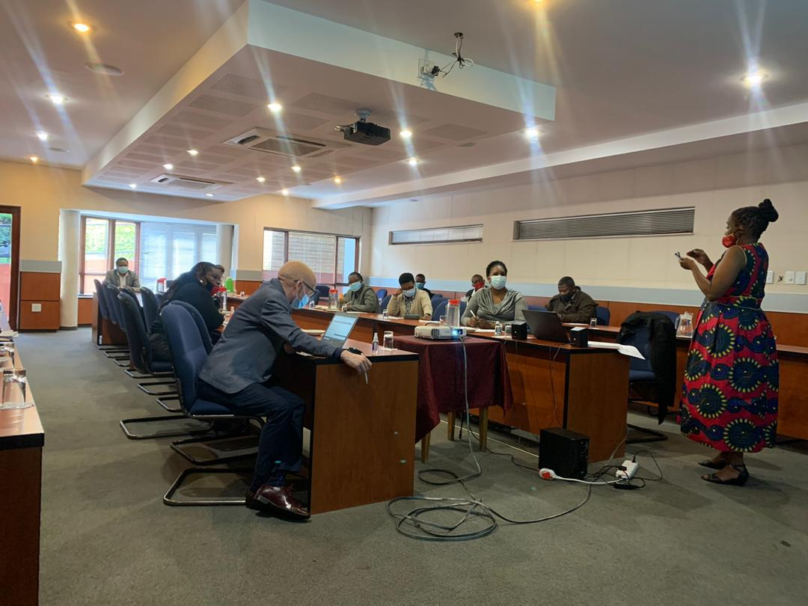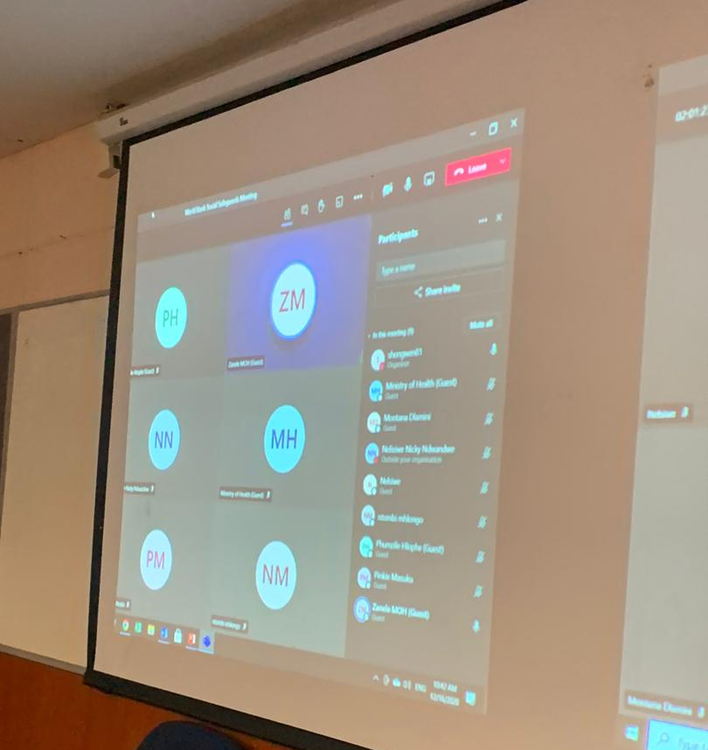
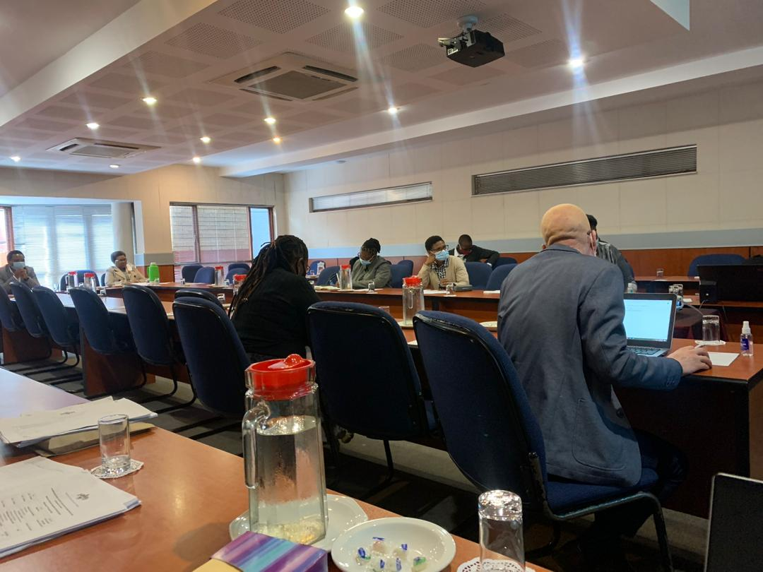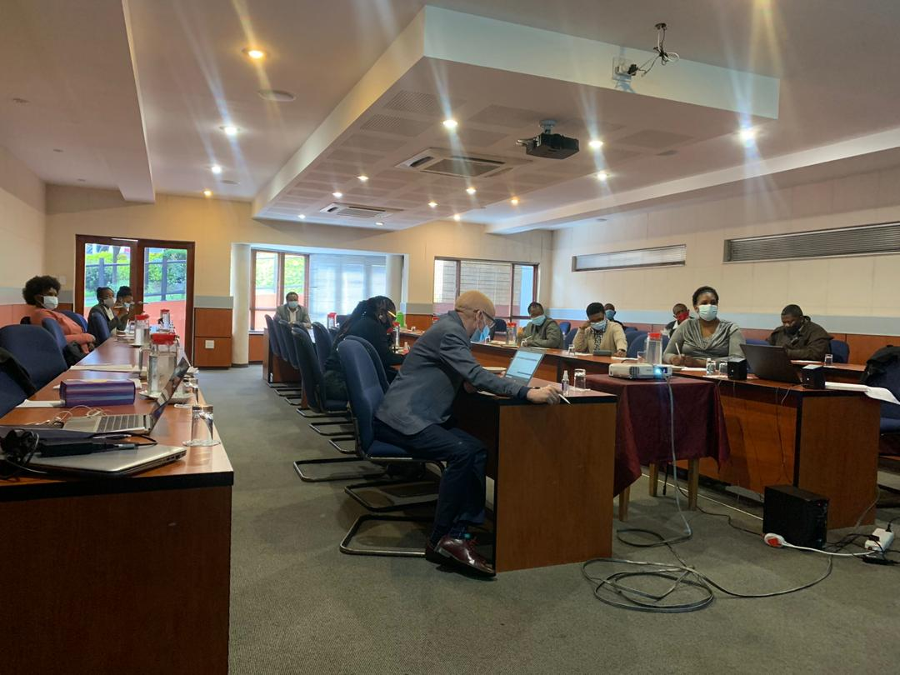
photo plate 1: Stakeholders in attendance at Workshop

- Closing Remarks
Mrs N Shongwe thanked all present stakeholders and mentioned that the consultant would appreciate feedback from the different stakeholders. She also urged the participants to work well with the ministry. Lastly, she stated the project will change the lives of children and then adjourned the meeting.

Annex 5: Template for establishment of stakeholders

Project Component 1: ECDE  - Coordination of ECDE services (Education/Nutrition/Health/WASH/Social protection)  - Development of policies and guidelines  - Mapping of ECD services  - Teaching / learning materials and professional development  - Targeted ECD centres to be supported | Project Component 2: Basic Education  - Improving Literacy and Numeracy in Early Grades  - Retention (Psycho-social support/ teen pregnancy/substance abuse)  - OVC Education program  - Girls and Boys Clubs  ICT enabled teaching and learning in Math and Science | Project Component 3: Employment to improvement of TVET  - TVET institutions  - National Qualifications Framework  - Priority economic sectors /labour markets  Youth ‘job’ Centres
PLEASE TICK THE COMPONENT MOST RELEVANT TO YOUR MANDATE ABOVE
Name: | Your Organisation: | Designation in organisation | Cell Number:  Email:
Key Objectives / mandate of your organisation (bullet points)
Your key roles and responsibilities under the project (bullet points)
Other than government ministries; who are your main partners? (List) and what is their key mandate?
What is the best method of contacting you?

What physical infrastructure activities do you anticipate under this project?
What environmental challenges do you anticipate arising from these activities?
What social factors present risks / challenges to the project?
What are possible mitigation measures?
What is the current status of WASH in the sector?
What possible mitigation measure need to be put in place?

Annex 6: Summary of inputs from consulted stakeholders
Other ministries | Curriculum / Teacher training | TVET institutions | Schools | Civil society organisations
- DPMO  - MTAD  - MoH  - MoSYAC | - National Curriculum Centre  - William Pitcher Teacher College | - Eswatini College of Technology  - EMlalatini Development Centre  - Gwamile Voctim  - Hosea Youth Centre | - Mahlabatsini BA Primary School  - Shining Stars Preschool  - Shewula Primary School  - Gija High School  - Tikhuba High School  - Mandulo High school  - Maphungwane Primary School  - St Johns Primary  - Intfutfuko Primary School  - Mpundle Primary School  - Ndlalane Primary School  - Ebenezah Primary School  - St Peters Primary School  - Matsanjeni Primary School  - Phumelele Primary  - Nkuntjini Primary  - Oslo Primary  - Nsalitje Primary  - Hlushwana Primary  - Zamokuhle DRC  - Siphofaneni Primary  - Madlenya Primary  - Engevini Primary  - Manyovu Primary  - St Philips Primary  - Duze Primary  - Mdlawini Primary  - Kazinyane Primary  - Lonhlalane Primary  - Mangweni Primary  - Nhlanguyavuka Primary  - Sdvokodvo Primary  - Damaseko Primary  - Emthonjeni Primary  - Nhlambeni Community  - Nhlambeni Nazarene  - Masundvwini Nazarene Primary | - Swaziland National Teachers Association  - Swaziland Principals’ Association  - UNESCO

Annex 7: Summary of stakeholder consultation
Issue/comment | Response
Clarification requested on the involvement of external stakeholders that the Ministry work with like UNICEF. | The information will be sourced from the project team on the role that those stakeholders play in this project. The consultants will then assist in determining their level of interest and influence in the project.
The project team indicated that priority stakeholders to be engaged, as they are partners in the project, are Ministry of Health, Deputy Prime Minister’s Office, Ministry of Sports, Youth, Arts and Culture, Ministry of Tinkhundla Administration and Development. | Comment was noted
A request was made for a template with the typical questions that will be asked during the engagements to be sent beforehand to make it easier and faster to go through discussions. | Template would be prepared and circulated before the workshop. This template is presented in annex IV.

Annex 8: Summary of stakeholder consultation
Stakeholder | Participants | Response to be considered in project design and implementation
Stakeholders engaged after the effective date
Mahlabatsini BA Primary (Grade 0) | Ms. Thobile Khumalo (MTK), Ms Bongekile Hlophe non-academic staff), Ms. Nomcebo Dlamini (teacher) | - No have physical classes for grade 0, lessons conducted in church.  - Learning equipment is also lacking.  - Since primary education is free parents are often reluctant to pay for grade 0.
Shining stars Preschool (Private) | Ms. Thobile Khumalo (MTK), Mr. Cinisela Dlamini (Principal) | - No problem with parents’ payments of school fees.  - Many classes for preschool education (2 classes for each of the 3 preschool years.  - Adequate equipment and learning aids
Shewula Primary | Ms. Lindokuhle Methule (MTK) Ms. Simphiwe Dlamini (MTK), | - Reading material provided in rural school libraries was reported to be inadequate and not up-to-date.  - Staff room not adequate for the staff compliment.  - Staff accommodation is also inadequate, leading to sharing amongst teachers and the potential for conflicts.
Mandulo High | Ms. Thobile Khumalo (MTK), Mr. Dludlu (principal) | - Low retention for both boys and girls (high activity of dagga trade)  - No positive role models, unemployment of graduates makes this issue worse.  - Parents do not want to pay; they expect everything to be free.  - There is a concern for reopening during the COVID pandemic since there will not be enough classes to allow social distancing  - The bridge gets flooded during heavy rains, affecting attendance of students.
Tikhuba High School | Ms. Lindokuhle Methule (MTK) Ms. Simphiwe Dlamini (MTK), Mr. Bongani Magongo (Senior teacher) | - Attempts to establish an internet connection via WI-FI was made in the past. This was unsuccessful; the company responsible for setting up the connection reported that the signal was too weak. Alternative means are still being considered. Internet connection is available for the IT lab, although it is not reliable. This connection is provided by EPTC.  - Water pumped from a spring into four 10 000 litre tanks. Takes three days to fill up a single tank because water levels have dropped drastically since 2015. In early 2020, an application was lodged with the Ministry of Natural Resources to request assist with digging a borehole.  - EPTC connection available. However, the service is not reliable. Outages are experienced often. EPTC sometimes reports that these issues are caused by people stealing copper wires. Cell phones are used for communication when EPTC service is not available. However, departments from the Ministries do not have these contact details and may not be able to get in contact with the school.  - Water supply to science labs is no longer available; the lab equipment is insufficient; lab chemicals are unavailable; desktops outdated; sporting equipment (tennis table, chess board) damaged.  - High drop-out rate due to teenage pregnancies, especially for lower grades and completing classes.  - Lack of public transport means that most students have to walk about 10km or more per day  - Students are normally tired during class due to walking distance between home and school  - Students arrive to school late due to lack of public transport and walking distance  - Road conditions influence school’s inability to retain teachers. Teachers normally work for a few months or few years then leave because the road damages their cars.  - The water pump is old and does not perform well. The school sometimes goes days with water when the pump is not functioning. The Ministry of Education provides water in tankers when this problem occurs, however the response is usually delayed.  - Limited number of students being enrolled into subjects due to the size of the classes. For example, most students are interested in studying Home Economics, but aren’t able to do that because the class can only take a certain number of students per class.
Gija High School | Ms. Sindi Nxumalo (MTK), Mr. Nxumalo (Principal) | - Key challenges are the teacher to student ratios in practical subjects. It should be noted that many learners are not academic and quickly lose interest if they are not ‘hands-on’. Even the practical subjects end up being theoretical in nature.  - The technical subjects need more space and more devices so that learners can have maximum contact time. There is need for more computer and design technology labs.  - Currently the computer lab is dominated by the learners who are preparing for exams as they are the priority. It means that other learners only get to work with computers when they get to form 4 which is too late.  - Although the school has access to electricity, many homes do not so learning ends at school.  - With regards to retention and related social challenges, the student numbers in classrooms make it difficult for learners and teachers to focus. Teachers are not well trained to handle the challenges they meet once in a real classroom setting and do not know how to engage with learners with different learning abilities. Learners routinely skip out on classes when they feel left behind. This leads to disciplinary issues. The current approach is not adapted to the needs of learners and of the market because all government money goes towards salaries but there is no discernable product. If this situation continues it will not only lead to more ‘drop-outs’ but ultimately to civil strife as we are failing our children.  - There have been some instances of theft of equipment so any new labs have to be secure.
- Maphungwane Primary School  - St Johns Primary  - Intfutfuko Primary School  - Mpundle Primary School  - Ndlalane Primary School  - Ebenezah Primary School  - St Peters Primary School  - Matsanjeni Primary School  - Phumelele Primary  - Nkuntjini Primary  - Oslo Primary  - Nsalitje Primary  - Hlushwana Primary  - Zamokuhle DRC  - Siphofaneni Primary  - Madlenya Primary  - Engevini Primary  - Manyovu Primary  - St Philips Primary  - Duze Primary  - Mdlawini Primary  - Kazinyane Primary  - Lonhlalane Primary  - Mangweni Primary  - Nhlanguyavuka Primary  - Sdvokodvo Primary  - Damaseko Primary  - Emthonjeni Primary  - Nhlambeni Community  - Nhlambeni Nazarene  - Masundvwini Nazarene Primary | Mr. Kenny Hlanze (E&S Specialist)  Mr. Sandile Shabangu (E&S Seconded Officer) | - Lack of water  - School has no ceiling and floors are rugged  - Grade 1 teacher is on contract and there is no water  - Grade 2 & 3 teacher on contract  - No grade 0  - Has grade 0 but parents unwilling to pay fees. Lack of water in the school  - A lot of vulnerable pupils and school has Grade 0  - No adequate toilets and no staff room  - No Grade 0 but there is a plan to introduce it in 2024.Lot of vulnerable pupils  - No parental support  - No Gade 0 and 60% vulnerability  - Parental involvement is available  - To introduce Grade 0 in 2024. School feeding insufficient  - Has Grade 0. Grade 1 teacher hired on a contractual bases and paid by the school  - Grade 0 available but no parental support. High rate of vulnerability. Water challenges  - Grade 1 teacher is volunteer and paid by the school  - 60% vulnerability. Most pupils stay with grandparents. There are water challenges  - 80% vulnerability. No Grade 0  - Grade 0 available. No parental support and 70% vulnerability  - Grade 2 teacher on contract  - No water as pump broken.Grade 0 available but no parental support  - 1 contract teacher and no Grade 0. Vulnerability 50%  - Grade 1 teacher on contract. Vulnerability high as most pupils stay with grandparents  - Grade 0 available. Parents very supportive.50% vulnerability  - Grade 0 available. Parents supportive and 50% vulnerability  - Grade 0 to start in 2024. No parental involvement and water harvested or bought  - Grade 0 no longer available as parents removed their kids due to fees. 80% vulnerability. No parental engagement  - School is being renovatyed. Replacement of new floors. Vulnerability 85%.Have Grade 0  - Grade 0 available and vulnerability 50%  - Grade 0 to be introduced next year  - Grade 0 available  - Parental involvement satisfactory. No Grade 0  - Vulnerability High 70%  - Poor parental support  - No Grade 0. No parental support
Gwamile VOCTIM | Ms. Sindi Nxumalo (MTK), Ms. Tenele Dlamini (VOCTIM), Mr. Musa Nyawo (VOCTIM) | - Basic education is divorced from practical skills training. There is a lack of skills training before learners reach tertiary level. As a result, most students enroll in vocational institutions as a stepping stone to university rather than an end in itself. This is further demonstrated by the majority of applicants opting for business and accounting courses because they aspire to white collar jobs.  - Those seeking internship opportunities after university discover that some companies are often reluctant to offer internships to local students.  - Lack of a National Qualification Framework. This means that it is not clear what the entry level for courses should be or the skills level acquired.  - There is also the challenge of scholarship unavailability.  - In response to COVID19 and other current developments, VOCTIM have acquired internet data for staff and students to enable online learning.
Emlalatini development Centre | Mr. Maseko (Principal Ms. Sindi Nxumalo (MTK), Ms. Thobile Khumalo (MTK), Ms. Lindo Methule, Ms. Simphiwe Dlamini | - No support for ICT learning and teaching  - The curriculum is print based, teachers need training to use ICT
Principal’s Association | Ms. Sindi Nxumalo (MTK), Mr. Welcome Mhlanga (Chairman) | TVET is the most neglected area. Those young people who chose to go into vocational training are not properly supported.  Universities and other institutions admit a very small percentage of high school graduates because of steep entry requirements.  Competency based education needs to be introduced in form 1 as much as its needed in grade 1.  Maintenance of school structures and equipment is behind as parents are not able to pay because of COVID.  High number of OVCs in many schools  Most schools have limited laboratories, especially ICT.  ICT is available as a subject, but it is not used as learning tool  PreVOC has been piloted for a long time, and has not been rolled out.
Swaziland National Association of Teachers | Ms. Sindi Nxumalo (MTK), Mr. Sikelela Dlamini (Secretary General) | Appreciates that competency-based education is in its third year and as SNAT they were consulted from the beginning of the project.  Request a report on results of grade 0 pilot for the 80 schools because they would like to see more grade 0 in public schools  There are only 16 pre-VOC pilot schools. The preVOC needs to be better supported and rolled out.  Secondary schools have seen an increase in core subjects (4 core and 3 elective). This means more students are failing high school because of the increase of the number pf core subjects that they have to pass.  Tertiary will benefit from the competency-based education because skills will be identified early  There is a need for benchmarking with other regional bodies.

Annex 9: Summary of stakeholder consultation
stakeholder | participant | response
Gwamile VOCTIM | Ms. Sindi Nxumalo (MTK), Ms. Tenele Dlamini (VOCTIM), Mr. Musa Nyawo (VOCTIM) | - Basic education is divorced from practical skills training. There is a lack of skills training before learners reach tertiary level. As a result, most students enroll in vocational institutions as a stepping stone to university rather than an end in itself. This is further demonstrated by the majority of applicants opting for business and accounting courses because they aspire to white collar jobs.  - Those seeking internship opportunities after university discover that some companies are often reluctant to offer internships to local students.  - Lack of a National Qualification Framework. This means that it is not clear what the entry level for courses should be or the skills level acquired.  - There is also the challenge of scholarship unavailability.  - In response to COVID19 and other current developments, VOCTIM have acquired internet data for staff and students to enable online learning.
Emlalatini development Centre | Mr. Maseko (Principal Ms. Sindi Nxumalo (MTK), Ms. Thobile Khumalo (MTK), Ms. Lindo Methule, Ms. Simphiwe Dlamini | - No support for ICT learning and teaching  - The curriculum is print based, teachers need training to use ICT
Principal’s Association | Ms. Sindi Nxumalo (MTK), Mr. Welcome Mhlanga (Chairman) | TVET is the most neglected area. Those young people who chose to go into vocational training are not properly supported.  Universities and other institutions admit a very small percentage of high school graduates because of steep entry requirements.  Competency based education needs to be introduced in form 1 as much as its needed in grade 1.  Maintenance of school structures and equipment is behind as parents are not able to pay because of COVID.  High number of OVCs in many schools  Most schools have limited laboratories, especially ICT.  ICT is available as a subject, but it is not used as learning tool  PreVOC has been piloted for a long time, and has not been rolled out.
Swaziland National Association of Teachers | Ms. Sindi Nxumalo (MTK), Mr. Sikelela Dlamini (Secretary General) | Appreciates that competency-based education is in its third year and as SNAT they were consulted from the beginning of the project.  Request a report on results of grade 0 pilot for the 80 schools because they would like to see more grade 0 in public schools  There are only 16 pre-VOC pilot schools. The preVOC needs to be better supported and rolled out.  Secondary schools have seen an increase in core subjects (4 core and 3 elective). This means more students are failing high school because of the increase of the number pf core subjects that they have to pass.  Tertiary will benefit from the competency-based education because skills will be identified early  There is a need for benchmarking with other regional bodies.

Annex 10: Summary of stakeholder consultation
Stakeholder | Participants | Response to be considered in project design and implementation
Mahlabatsini BA Primary (Grade 0) | Ms. Thobile Khumalo (MTK), Ms Bongekile Hlophe non-academic staff), Ms. Nomcebo Dlamini (teacher) | - No have physical classes for grade 0, lessons conducted in church.  - Learning equipment is also lacking.  - Since primary education is free parents are often reluctant to pay for grade 0.
Shining stars Preschool (Private) | Ms. Thobile Khumalo (MTK), Mr. Cinisela Dlamini (Principal) | - No problem with parents’ payments of school fees.  - Many classes for preschool education (2 classes for each of the 3 preschool years.  - Adequate equipment and learning aids
Shewula Primary | Ms. Lindokuhle Methule (MTK) Ms. Simphiwe Dlamini (MTK), | - Reading material provided in rural school libraries was reported to be inadequate and not up-to-date.  - Staff room not adequate for the staff compliment.  - Staff accommodation is also inadequate, leading to sharing amongst teachers and the potential for conflicts.
Mandulo High | Ms. Thobile Khumalo (MTK), Mr. Dludlu (principal) | - Low retention for both boys and girls (high activity of dagga trade)  - No positive role models, unemployment of graduates makes this issue worse.  - Parents do not want to pay; they expect everything to be free.  - There is a concern for reopening during the COVID pandemic since there will not be enough classes to allow social distancing  - The bridge gets flooded during heavy rains, affecting attendance of students.
Tikhuba High School | Ms. Lindokuhle Methule (MTK) Ms. Simphiwe Dlamini (MTK), Mr. Bongani Magongo (Senior teacher) | - Attempts to establish an internet connection via WI-FI was made in the past. This was unsuccessful; the company responsible for setting up the connection reported that the signal was too weak. Alternative means are still being considered. Internet connection is available for the IT lab, although it is not reliable. This connection is provided by EPTC.  - Water pumped from a spring into four 10 000 litre tanks. Takes three days to fill up a single tank because water levels have dropped drastically since 2015. In early 2020, an application was lodged with the Ministry of Natural Resources to request assist with digging a borehole.  - EPTC connection available. However, the service is not reliable. Outages are experienced often. EPTC sometimes reports that these issues are caused by people stealing copper wires. Cell phones are used for communication when EPTC service is not available. However, departments from the Ministries do not have these contact details and may not be able to get in contact with the school.  - Water supply to science labs is no longer available; the lab equipment is insufficient; lab chemicals are unavailable; desktops outdated; sporting equipment (tennis table, chess board) damaged.  - High drop-out rate due to teenage pregnancies, especially for lower grades and completing classes.  - Lack of public transport means that most students have to walk about 10km or more per day  - Students are normally tired during class due to walking distance between home and school  - Students arrive to school late due to lack of public transport and walking distance  - Road conditions influence school’s inability to retain teachers. Teachers normally work for a few months or few years then leave because the road damages their cars.  - The water pump is old and does not perform well. The school sometimes goes days with water when the pump is not functioning. The Ministry of Education provides water in tankers when this problem occurs, however the response is usually delayed.  - Limited number of students being enrolled into subjects due to the size of the classes. For example, most students are interested in studying Home Economics, but aren’t able to do that because the class can only take a certain number of students per class.
Gija High School | Ms. Sindi Nxumalo (MTK), Mr. Nxumalo (Principal) | - Key challenges are the teacher to student ratios in practical subjects. It should be noted that many learners are not academic and quickly lose interest if they are not ‘hands-on’. Even the practical subjects end up being theoretical in nature.  - The technical subjects need more space and more devices so that learners can have maximum contact time. There is need for more computer and design technology labs.  - Currently the computer lab is dominated by the learners who are preparing for exams as they are the priority. It means that other learners only get to work with computers when they get to form 4 which is too late.  - Although the school has access to electricity, many homes do not so learning ends at school.  - With regards to retention and related social challenges, the student numbers in classrooms make it difficult for learners and teachers to focus. Teachers are not well trained to handle the challenges they meet once in a real classroom setting and do not know how to engage with learners with different learning abilities. Learners routinely skip out on classes when they feel left behind. This leads to disciplinary issues. The current approach is not adapted to the needs of learners and of the market because all government money goes towards salaries but there is no discernable product. If this situation continues it will not only lead to more ‘drop-outs’ but ultimately to civil strife as we are failing our children.  - There have been some instances of theft of equipment so any new labs have to be secure.
- Maphungwane Primary School  - St Johns Primary  - Intfutfuko Primary School  - Mpundle Primary School  - Ndlalane Primary School  - Ebenezah Primary School  - St Peters Primary School  - Matsanjeni Primary School  - Phumelele Primary  - Nkuntjini Primary  - Oslo Primary  - Nsalitje Primary  - Hlushwana Primary  - Zamokuhle DRC  - Siphofaneni Primary  - Madlenya Primary  - Engevini Primary  - Manyovu Primary  - St Philips Primary  - Duze Primary  - Mdlawini Primary  - Kazinyane Primary  - Lonhlalane Primary  - Mangweni Primary  - Nhlanguyavuka Primary  - Sdvokodvo Primary  - Damaseko Primary  - Emthonjeni Primary  - Nhlambeni Community  - Nhlambeni Nazarene  - Masundvwini Nazarene Primary | Mr. Kenny Hlanze (E&S Specialist)  Mr. Sandile Shabangu (E&S Seconded Officer) | - Lack of water  - School has no ceiling and floors are rugged  - Grade 1 teacher is on contract and there is no water  - Grade 2 & 3 teacher on contract  - No grade 0  - Has grade 0 but parents unwilling to pay fees. Lack of water in the school  - A lot of vulnerable pupils and school has Grade 0  - No adequate toilets and no staff room  - No Grade 0 but there is a plan to introduce it in 2024.Lot of vulnerable pupils  - No parental support  - No Gade 0 and 60% vulnerability  - Parental involvement is available  - To introduce Grade 0 in 2024. School feeding insufficient  - Has Grade 0. Grade 1 teacher hired on a contractual bases and paid by the school  - Grade 0 available but no parental support. High rate of vulnerability. Water challenges  - Grade 1 teacher is volunteer and paid by the school  - 60% vulnerability. Most pupils stay with grandparents. There are water challenges  - 80% vulnerability. No Grade 0  - Grade 0 available. No parental support and 70% vulnerability  - Grade 2 teacher on contract  - No water as pump broken.Grade 0 available but no parental support  - 1 contract teacher and no Grade 0. Vulnerability 50%  - Grade 1 teacher on contract. Vulnerability high as most pupils stay with grandparents  - Grade 0 available. Parents very supportive.50% vulnerability  - Grade 0 available. Parents supportive and 50% vulnerability  - Grade 0 to start in 2024. No parental involvement and water harvested or bought  - Grade 0 no longer available as parents removed their kids due to fees. 80% vulnerability. No parental engagement  - School is being renovatyed. Replacement of new floors. Vulnerability 85%.Have Grade 0  - Grade 0 available and vulnerability 50%  - Grade 0 to be introduced next year  - Grade 0 available  - Parental involvement satisfactory. No Grade 0  - Vulnerability High 70%  - Poor parental support  - No Grade 0. No parental support
Gwamile VOCTIM | Ms. Sindi Nxumalo (MTK), Ms. Tenele Dlamini (VOCTIM), Mr. Musa Nyawo (VOCTIM) | - Basic education is divorced from practical skills training. There is a lack of skills training before learners reach tertiary level. As a result, most students enroll in vocational institutions as a stepping stone to university rather than an end in itself. This is further demonstrated by the majority of applicants opting for business and accounting courses because they aspire to white collar jobs.  - Those seeking internship opportunities after university discover that some companies are often reluctant to offer internships to local students.  - Lack of a National Qualification Framework. This means that it is not clear what the entry level for courses should be or the skills level acquired.  - There is also the challenge of scholarship unavailability.  - In response to COVID19 and other current developments, VOCTIM have acquired internet data for staff and students to enable online learning.
Emlalatini development Centre | Mr. Maseko (Principal Ms. Sindi Nxumalo (MTK), Ms. Thobile Khumalo (MTK), Ms. Lindo Methule, Ms. Simphiwe Dlamini | - No support for ICT learning and teaching  - The curriculum is print based, teachers need training to use ICT
Principal’s Association | Ms. Sindi Nxumalo (MTK), Mr. Welcome Mhlanga (Chairman) | TVET is the most neglected area. Those young people who chose to go into vocational training are not properly supported.  Universities and other institutions admit a very small percentage of high school graduates because of steep entry requirements.  Competency based education needs to be introduced in form 1 as much as its needed in grade 1.  Maintenance of school structures and equipment is behind as parents are not able to pay because of COVID.  High number of OVCs in many schools  Most schools have limited laboratories, especially ICT.  ICT is available as a subject, but it is not used as learning tool  PreVOC has been piloted for a long time, and has not been rolled out.
Swaziland National Association of Teachers | Ms. Sindi Nxumalo (MTK), Mr. Sikelela Dlamini (Secretary General) | Appreciates that competency-based education is in its third year and as SNAT they were consulted from the beginning of the project.  Request a report on results of grade 0 pilot for the 80 schools because they would like to see more grade 0 in public schools  There are only 16 pre-VOC pilot schools. The preVOC needs to be better supported and rolled out.  Secondary schools have seen an increase in core subjects (4 core and 3 elective). This means more students are failing high school because of the increase of the number pf core subjects that they have to pass.  Tertiary will benefit from the competency-based education because skills will be identified early  There is a need for benchmarking with other regional bodies.

Annex 11: Initial Stakeholder consultations
The planning officers at MoET introduced the consultants to their inter-ministerial partners availing them the opportunity to refocus on planned project activities and reflect on their potential roles and responsibilities. These stakeholders include:
- Deputy Prime Minister’s Office
- Ministry of Tinkhundla Administration and Development
- Ministry of Health
- Ministry of Sports and Youth Affairs
The consultations provided a platform for stakeholders to raise any concerns or existing issues within the education sector. The following table summarizes initial inputs from these stakeholders. The concerns and issues raised by stakeholders in their responses should be taken into consideration as the project design is finalised.

Stakeholder | Participants | Summary of issues/concerns raised
Deputy Prime Minister’s Office | Ndlangamandla - DPMO  Nkhululeko Gwebu - MoET  Sindi Nxumalo – MTK | There is a need to ‘reimagine children’s services as the environment for children in the country is currently hostile. There is a need for environmentally safe and healthy friendly Neighbourhood Care Point (NCP) facilities.  The department is currently preparing to submit a multi-sectorial framework for ECCE to cabinet.
Ministry of Tinkhundla Administration and Development | Dumisani Sithole – MoT  Nkhululeko Gwebu - MoET  Nonhlanhla Shongwe -MoET  Sindi Nxumalo – MTK | Although this was the ministry’s remit in the past, recently all aspects of children’s welfare are with the DPMO. The ministry can provide background to the current situation.  Linkages between policy and implementation should take into account ‘Ínkhundla Development Plans’ that look at all aspects of the population across sectors. These take into account environmental issues and make plans for protection and sustainability.
Ministry of Sports and Youth Affairs | Mfanfikile Mabuza - MoYSAC  Nkhululeko Gwebu - MoET  Sindi Nxumalo – MTK | The ministry relies on partners in youth development as they do not have the internal capacity to implement many projects. To that end they develop proposals for implementing partners. The ministry undertakes to provide the team with contact details of their key partners.
Ministry of Health | Dumisani Shongwe- MoH  Nkhululeko Gwebu - MoET  Nonhlanhla Shongwe -MoET  Sindi Nxumalo – MTK | MoET and MoH are always closely associated as both health and education affect children and youth. There a number of specific departments within the MoH where program officers deal with such issues as early childhood health; Immunisation; nutrition; adolescent health; Teen pregnancy etc. It will be important for the team to engage with these officers directly.  MoH has recently undergone the process of developing an ESMF and SEP and would be willing to advise MoET on any aspects.
Ministry of Sports, Culture and Youth Affairs | Ms Thobile Khumalo, Mr. Dlamini, Mr. Hlatshwayo | The ministry established 16 youth centres, each under an Inkhundla. Upon lack of funding to sustain, these structures are now dilapidated and all equipment and building materials was stolen.  There is a need to rehabilitate these and make sure the projects are linked to the respective Tinkhundla for sustainability of the youth centre initiatives.  The plan is to rehabilitate, bring in equipment, train youth in the youth centres on skills, entrepreneurship, and provide start-up funds for businesses  There are issues of chieftaincy disputes in some areas, which affect smooth operation of these centres.  Youth centres close to the border experience issues with continuity as there is seasonal migration of youth across the border
Ministry of Information, Communication and Technology (MICT) | Mr. Sakhile Dlamini (Senior Communication Engineer) | MoET and MICT coordination is very weak, leading to the Ministry missing out on key ICT projects and opportunities. The ministry considers ICT as a subject and not a tool that needs to be integrated in learning.  The EPTC experiences issues of copper wire theft

Annex 11: Stakeholder workshop
A half-day stakeholders’ workshop was held on 16th December 2020. The workshop was aimed at:
- Explaining the process of formulating the ESMF and the SEP
- Introducing the consultants
- Agreeing activities necessary to achieve the stated objectives under each component
- Ascertaining the roles and responsibilities of stakeholders
- Identifying other stakeholders
- Ascertaining the level of Interest and / influence of stakeholders
- Determining the preferred / appropriate method and frequency of engagements with stakeholders.
The workshop was attended by 31 participants of which male representing 55% and female representing 45%. Workshop participants represented:
- Ministry of Education
- Ministry of Sports, Culture and Youth Affairs
- Ministry of Information. Communication and Technology
- National Curriculum Centre
- Eswatini College of Technology
- Mlalatini Development Centre
- William Pitcher Teacher College
- UNESCO
Participants met in person in a large conference room to maintain social distancing as well as via video link.
The tables below outline the summary of workshop discussions. The input from stakeholders should be taken into consideration in further developing the project design and implementation.
Table 2: Component 1 Discussions
Project Component 1: ECDE
- Coordination of ECDE services (Education/Nutrition/Health/WASH/Social protection)
- Development of policies and guidelines
- Mapping of ECD services
- Teaching / learning materials and professional development
Targeted ECD centres to be supported
Key stakeholders - Key roles and responsibilities under the project | Ministry of Health  Deputy Prime Minister’s Office – Coordination of child services  National Curriculum Centre – standardised curriculum  INSET – In service training  Exams Council
Current status | - Grade 1 curriculum to be piloted in 80 centres in 2021.  - There is need for a standard assessment tool for school readiness and for mental health assessment to assist special education.  - Identified ‘Care Centres’ will need renovations as they are not up to standard as learning establishments.
Other key partners identified  (to be consulted within two months of project effectiveness) | The Early Childhood Development Network - coordination  UNICEF – child welfare and policy assistance  UNESCO – policy framework  WFP – nutritional support  Parents and guardians are crucial partners at ECDE level as all activities need their consent. This is especially true with increased dependence on home learning and because they bear the costs of ECDE.
Best method of communication | Email and WhatsApp (indicated by stakeholders as preferred communication methods)

Table 12 shows inputs from stakeholders, who also assisted in the identification of more stakeholders relevant in the project. Further consultation will be undertaken with these stakeholders identified. The input from stakeholders should be taken into consideration in further developing the project design and implementation.
Table 3: Component 2 Discussions
Project Component 2: Basic Education
- Improving Literacy and Numeracy in Early Grades
- Retention (Psycho-social support/ teen pregnancy/substance abuse)
- OVC Education program
- Girls and Boys Clubs
ICT enabled teaching and learning in Math and Science
Key stakeholders - Key roles and responsibilities under the project | The stakeholders for this component are similar to those in component 1.  Mlalatini Development centre - study centres (in schools)  Ministry of ICT
Current status | A key challenge is that ICT is seen as a subject within the Ministry of Education and Training rather than as a tool through which to teach all subjects. It is generally felt that Subject panels in the MoET do not have the capacity to leverage technologies for teaching and learning. There is need for a curriculum that integrates and utilises IT as a teaching tool. Hardware and software costs are seen as prohibitive as well as rural connectivity is also a key challenge.
Other key partners identified  (to be consulted within two months of project approval) | Head teachers- Implementing curriculum changes  School committee chairpersons - facilitating ‘Boys and Girls Clubs’.  SWAGGAA – Psychosocial support  World Vision – Girls education  Kwakha Indvoza – holistic education targeting boys and young men  MacMillan Publishers – print based materials / stationary  The Commonwealth of Learning- project funding
Best method of communication | Email and WhatsApp

Vulnerable status may stem from an individual’s or group’s race, national, ethnic or social origin, colour, gender, language, religion, political or other opinion, property, age, culture, literacy, sickness, physical or mental disability, poverty or economic disadvantage, and dependence on unique natural resources.
This component has since been identified as a separate project to be addressed at a later date.
7 participated on the Zoom platform. 4 of the women participates were from the consultant team.

